Name: _______________ Class: ______ Number: ____
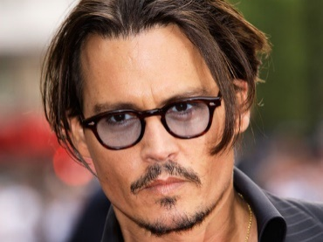
SAVE THE DUCKS
I know him. He is Johnny Depp.
I don’t like him. He isn’t cool.
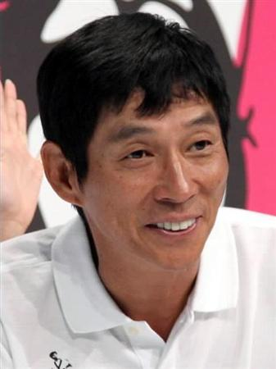
Do you know him?
______________________________________________________
______________________________________________________
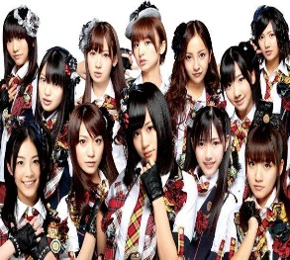
Do you know them?
______________________________________________________
______________________________________________________
Do you know him?
______________________________________________________
______________________________________________________
Do you know it?
______________________________________________________
______________________________________________________
Do you know her?
______________________________________________________
______________________________________________________
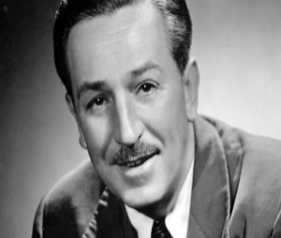
Do you know him?
______________________________________________________
______________________________________________________
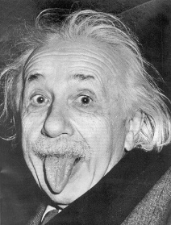
Do you know him?
______________________________________________________
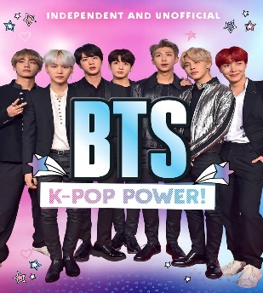
______________________________________________________
Do you know them?
______________________________________________________
______________________________________________________
Do you know her?
______________________________________________________
______________________________________________________
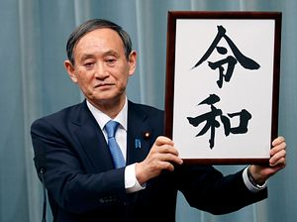
Do you know him?
______________________________________________________
______________________________________________________
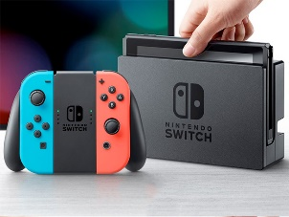
Do you know it?
______________________________________________________
______________________________________________________
Do you know her?
______________________________________________________
______________________________________________________
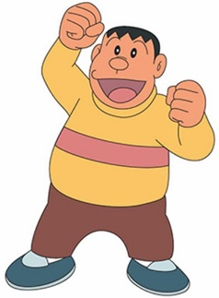
Do you know him?
______________________________________________________
______________________________________________________
TEAM _________

TEAM _________

