Entering the staff room
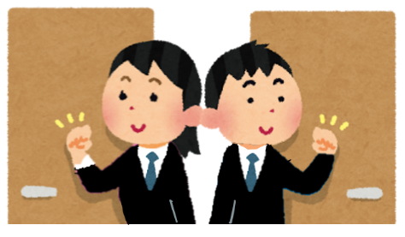
Excuse me.
しつれいします。
I’m ( なまえ ) from class ( _ )-( _ ).
year
class

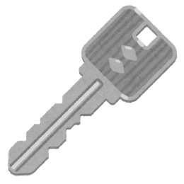
May I borrow the key to class ( _ )-( _ )?
year
class
かりてもよろしいですか
May I borrow the ( きょうしつ なまえ ) key?
I am returning the key. May I come in?
はいってもよろしいですか。
かえしています

Is (Ms. / Mr.) ( 先生の名前 ) here?
○○先生はいらっしゃいますか。

Thank you.

