Name __________________________ Class ____ Number____

**I’m cooking**

**ramen now.**

**What are you doing now?**





**Step 1.** Match the words with the pictures.

**Step 2.** Find your “X”. (Your teacher will write an X.)

**Step 3.** Ask a boy and a girl: “What are you doing now?”

* eat lunch
* study English
* walk the dog
* play TV games

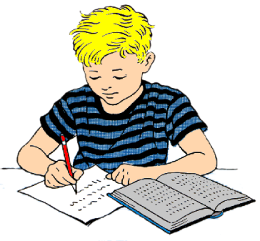

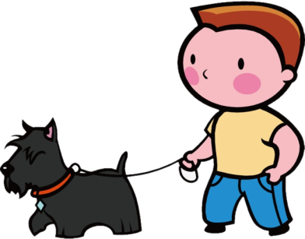

I’m ________________________

___________________________.

I’m ________________________

___________________________.

X



I’m ________________________

___________________________.

I’m ________________________

___________________________.

**Yes, I am./No, I’m not.**

**One!**

**Are you _____ing _________ now?**





|  |  |  |
| --- | --- | --- |
| Are you cooking | ramen | now? |
| pizza |
| Are you eating | steak | today? |
| rice |

**Try to guess your partner’s sentence!**

**Please write your guesses here. Your partner can only answer “0, 1, 2 or 3”. 0,1,2,3**

|  |  |  |  |
| --- | --- | --- | --- |
|  |  |  |  |
|  |  |  |  |
|  |  |  |  |
|  |  |  |  |
|  |  |  |  |
|  |  |  |  |