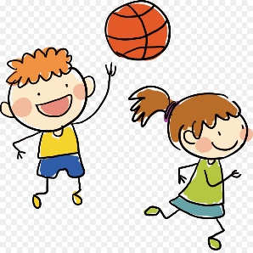
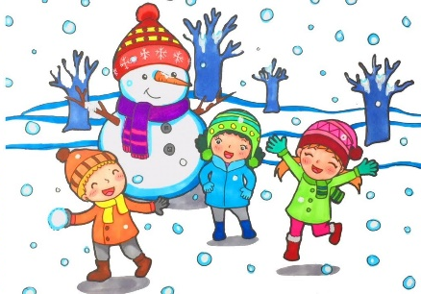
Name: ____________________
When I was…

in first grade at this school, | in second grade at my old school,
in sixth grade at my old school, | in first grade at my old school,
in fifth grade at my old school, | in kindergarten,
in fourth grade at my old school, | in the spring vacation,
in third grade at my old school, | a baby,

- __________________________________________________
__________________________________________________
__________________________________________________

- __________________________________________________
__________________________________________________
__________________________________________________

- __________________________________________________
__________________________________________________
__________________________________________________

- __________________________________________________
__________________________________________________
__________________________________________________

