February 16, 2024
1st Grade:

Lesson 9-2: There is ~, There are ~ (pages 114-115)

Activity Name:  True or False  Find The Box | Mechanics:  - The class will be divided into pairs.  - Each student will receive a worksheet.  - Student B will secretly choose a box from 1-25.  - Student A will try to guess Student B’s box, by saying sentences about the box.  There is a (dog / panda / cat / rabbit / lion) in the box.  There are many (strawberries / grapes / oranges / watermelons / bananas) in the box.  - For each sentence of Student A, Student B to respond with True/False.  - By process of elimination, Student A to make a guess of Student B’s box from 1-25.  - After Student A guesses correctly, they exchange roles.
Target Language Skill:
Speaking, Writing
Topic/Theme:
There is/are _____.
Materials:
Worksheet, pencils
Mode:
By Pair
Estimated Time:
25 minutes

5 minutes – Instructions
10 minutes – Game
10 minutes - Writing

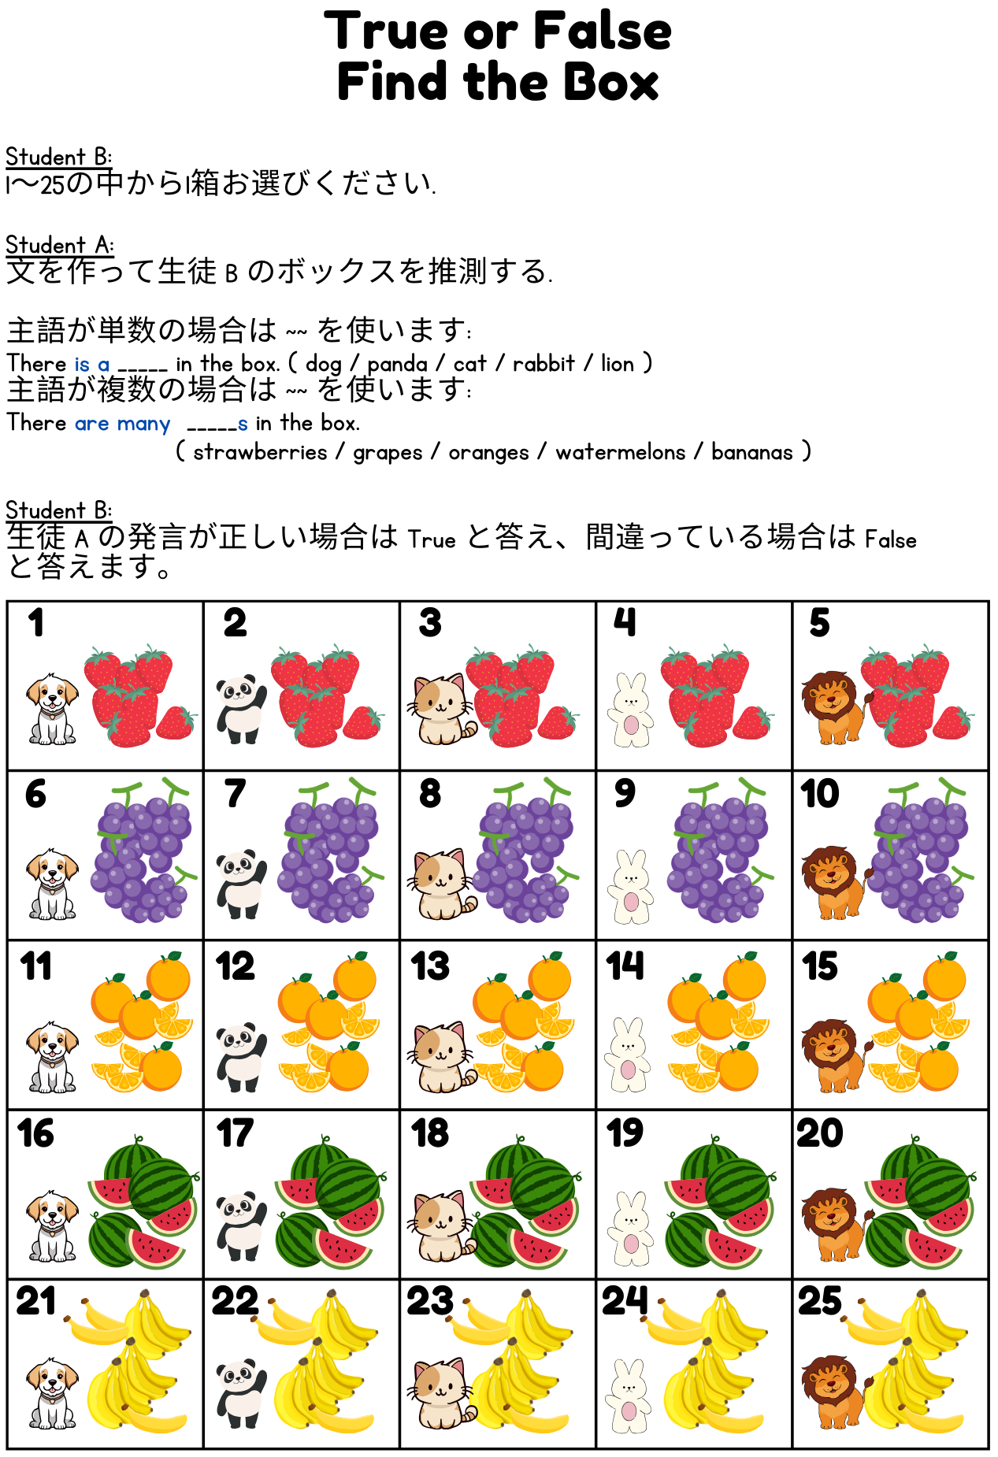

Name: _______________________________________________

Find The Box

主語が単数の場合は ~~ を使います:
There is a _____ in the box. ( dog / panda / cat / rabbit / lion )
主語が複数の場合は ~~ を使います:
There are many _____s in the box.
( strawberries / grapes / oranges / watermelons / bananas )

Write 2 sentences about your Box:
ボックスについて 2 つの文を書いてください:

___________________________________________________________

___________________________________________________________

Write 2 sentences about your partner’s Box:
パートナーのボックスについて 2 つの文を書きます:

___________________________________________________________

___________________________________________________________

