**My Best Memory**



What’s your best memory?

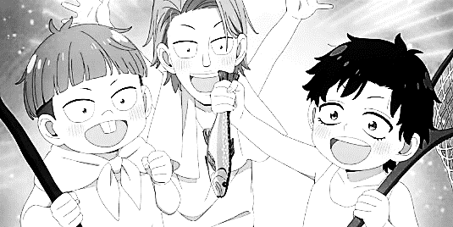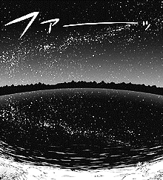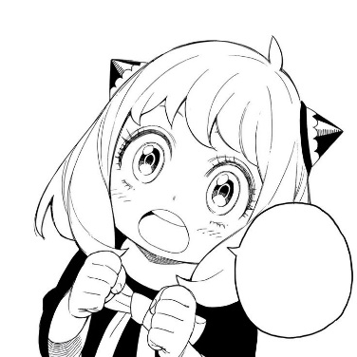

My best memory is our field trip!

We went fishing…

We enjoyed eating fresh fish for dinner…

We saw Stella Lake…

It was beautiful.

Sound’s fun! I want to go too!