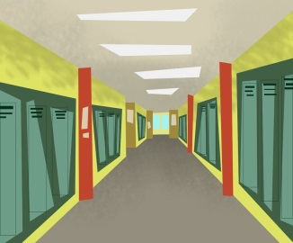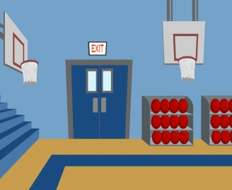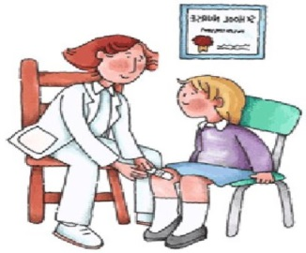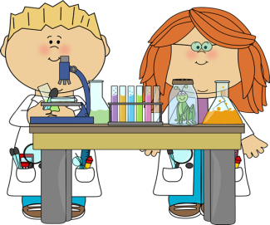

**Points**

2

**Points**

Yes, I was. (+1ポイント)

Were you in the ~ at 3:30?

No, I wasn’t (0ポイント)

Yes, I was. (+1ポイント)

No, I wasn’t (0ポイント)

Yes, I was. (+1ポイント)

No, I wasn’t (0ポイント)

school grounds

hallway

teacher’s office

Were you in the ~ at 2:00?

Were you in the ~ at 10:00?

Were you in the library at 10:00?

Were you in the classroom at 2:00?

Were you in the gym at 3:30?

Yes, I was. (+1ポイント)

Yes, I was. (+1ポイント)

No, I wasn’t. (+0ポイント)

**Were you at school?**

**Name: __________________**

**Q3**

**Q2**

**Q1**

nurse’s office

gym

science lab

classroom

lunch room

library