
Lets eat some fast food! Look at the menu.
Food |  | Price |  |  |  |  | Price
 |  | ( )  $ |  |  |  |  | ( )  $
 |  | ( )  $ |  |  |  |  | ( )  Large  $  Small  $
 |  | ( )  $ |  |  |  |  | ( )  $
Drinks | Price |  |  | Price |  |  |  | Price
Fruit Juice 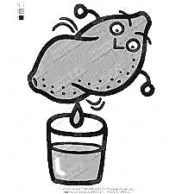 | Small (250ml)  $ 1.50  Medium (0.5l)  $ 2  Large (2L)  $ 4 |  | Cola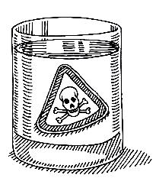 | Small (250ml)  $ 1.50  Medium (0.5l)  $ 2  Large (2L)  $ 4 |  | Water  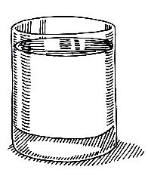 |  | Small (250ml) Medium (0.5l)  Large (2L)  $ free
① Write the prices on the menu. ＊What are the options?
② Look at the menu and decide what you will have.
＊What will you have to eat?
(意味： ？)
I will have ① 。It costs 。
I will have ② 。It costs 。
＊What will you have to drink?
(意味： ？)
I will have 。It costs 。
＊How much does you lunch cost?
(意味： ？)
My lunch is dollars cents。

③ Listen to the conversation below. ＊Write the meaning in Japanese.
 | Staff 店員 | Customer お客さん
注文は？ | Hello! May I help you?
Yes. I’ll have ① ,
② and please
サイズ？ | Which size  would you like?
 |  | Small, Medium, Large please
どこ？ | For here or to go?
 |  | For here ! To go !
 | Would you like anything else?
 |  | No. That’s all. Thanks
値段は？ | OK. That’ll be , please.
 |  | Here you are.
 | Thank you.

④ Practice your conversation in pairs. ＊Listen and find the price of your partner’s meal.
a) Now repeat with as many people as you can in 3 mins.
Note: Clasmate = 1 point English Teacher = 2 points <AET> = 3 points
Name | Name | Name | Name | Name
Name | Name | Name | Name | Name

⑤ Money Money! Now you have some money! See how much you can buy?
＊What will you have?
I will have ① 。It costs 。
I will have ② 。It costs 。
I will have ③ 。It costs 。
I will have ④ 。It costs 。
I will have ④ 。It costs 。

How much change will you have?

