

1

I ( ) hungry.

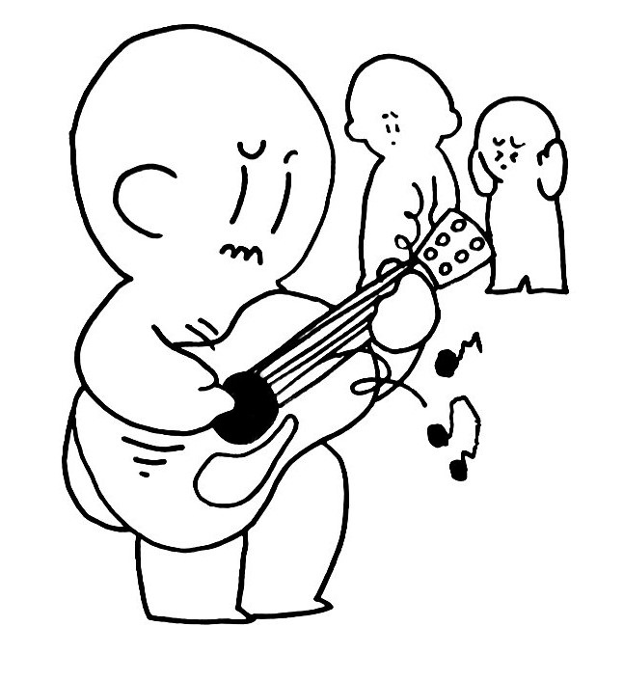

2

I ( ) ( ) good at the guitar.

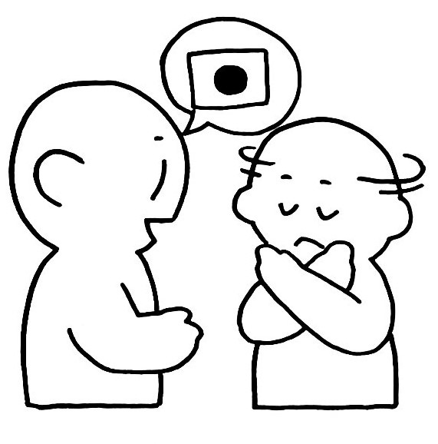

3

I ( ) ( ) from Japan.

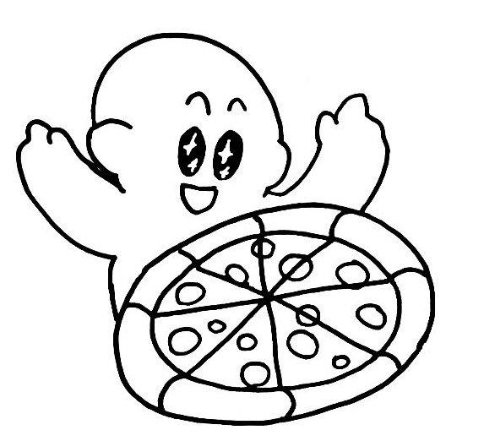

4

I ( ) pizza.

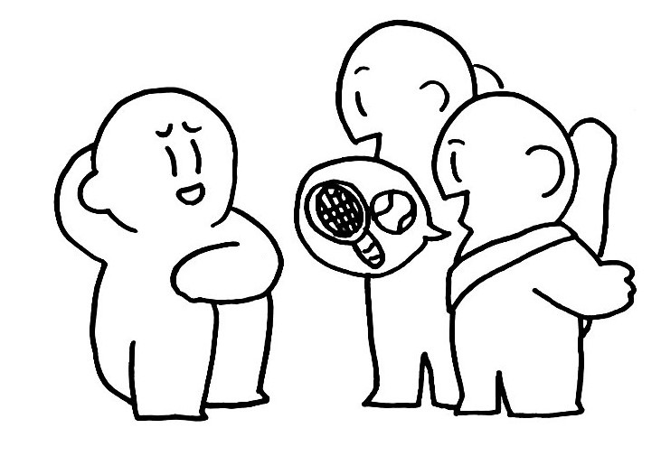

5

I ( ) ( ) play tennis.

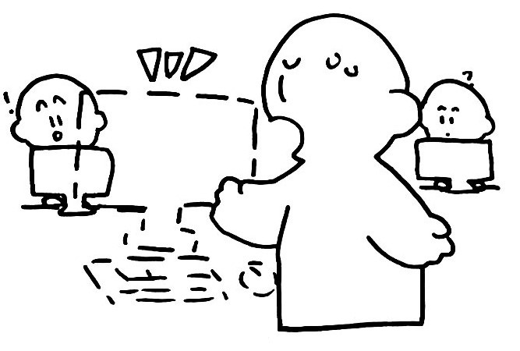

6

I ( ) ( ) have a computer.