過去形Writing Practice!

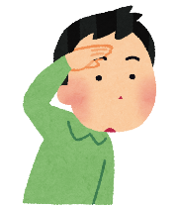

saw

ソー

ウェント

went

[goの過去形]

**行った**

[seeの過去形]

**見た**

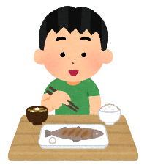

had

ハド

エイト

ate

[eatの過去形]

**食べた**

[haveの過去形]

**持った**



エンジョイド

[enjoyの過去形]

**楽しんだ**

enjoyed

|  |
| --- |
|  |
|  |
|  |

|  |
| --- |
|  |
|  |
|  |

|  |
| --- |
|  |
|  |
|  |

|  |
| --- |
|  |
|  |
|  |

|  |
| --- |
|  |
|  |
|  |