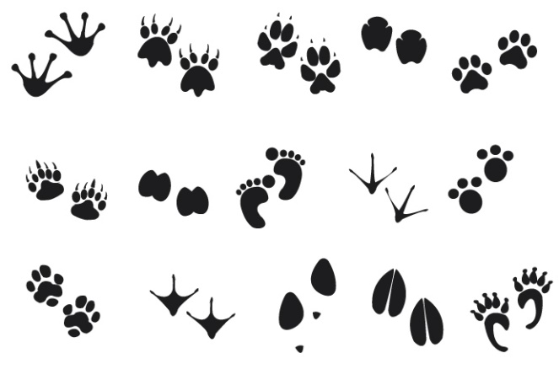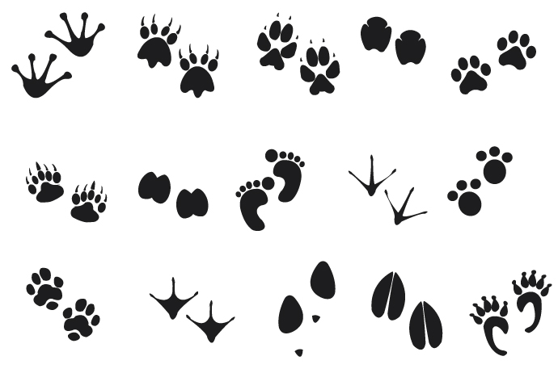

Name:__________________

Student Number:____________

Animal Research Project



Animal Name:____________

Animal Facts



Weight:___________________________

Height:___________________________

Color:____________________________

It has: Fur/Feather/Skin/Scale/Shell

Lifespan:__________________________

Diet:______________________________________________________________

Habitat:____________________________________________________________









Animal Habitat:











Example

Example

Animal Research Project



Leopard

Animal Name:____________

Animal Facts

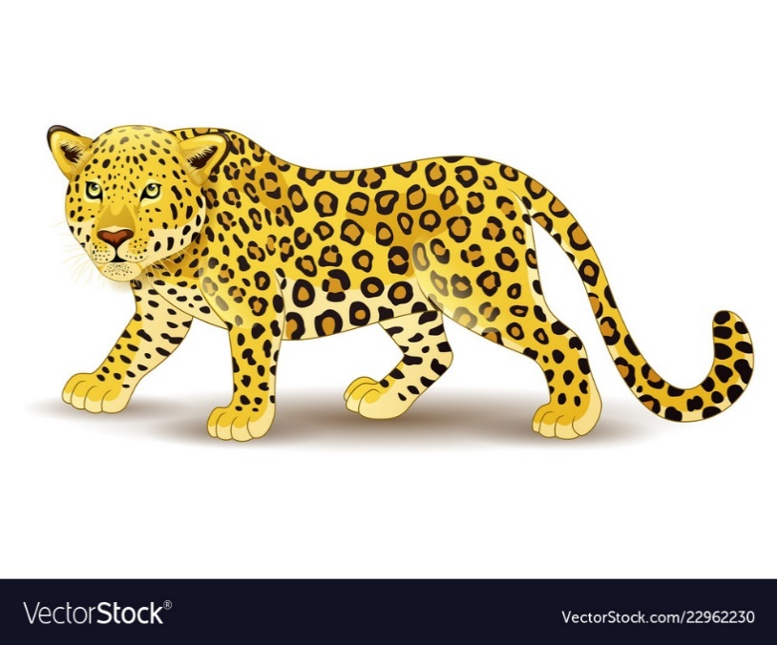

 30.9–72 kilograms

Weight:___________________________

Height:___________________________

Color:____________________________

It has: Fur/Feather/Skin/Scale/Shell

Lifespan:__________________________

Diet:______________________________________________________________

Habitat:____________________________________________________________



60–70 centimeters

yellow with black spots





 10 and 12 years



fish, birds, rabbits, antelopes

Animal Habitat:

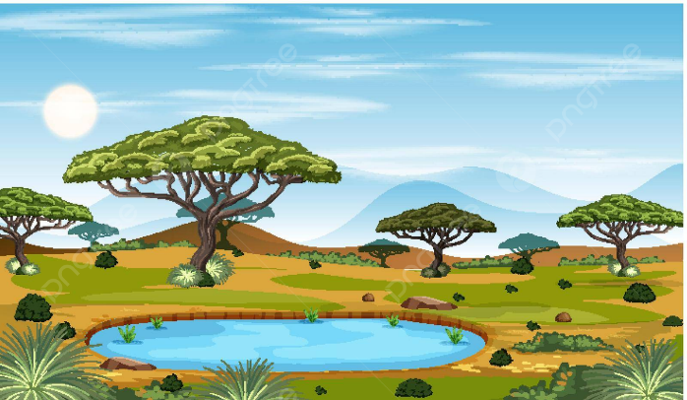

sheep, zebras, goats, and pigs



Africa and Asia in



forests, savannas and grasslands

