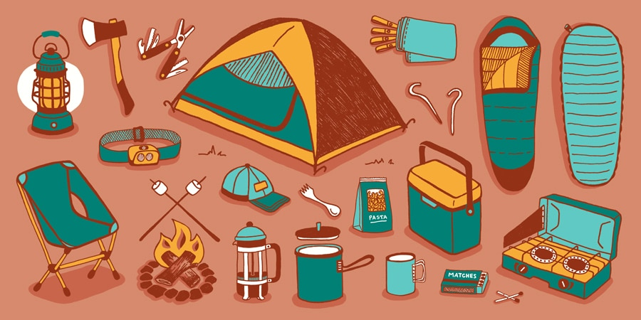
Let’s go camping!

lanterns | wood | a coffee maker
an axe | marshmallows | lunch boxes
flashlights | tents | pasta
a guitar | sunscreen | bug spray
a multi-tool | a hat | mugs
chairs | forks | matches
scarves | hooks | sleeping bags
water | a cooler | a stove
Plan with your camping group!
NAME | marshmallow | matches | curry

Writing Challenge:
Example:
We should bring marshmallows.
We should eat s’mores.
I don’t think we should bring a stove. We should enjoy the campfire!
I think we have to pack matches.
We don’t have to eat pasta.
We should bring curry!

We should ______________________________________________
We should ______________________________________________
I don’t think we should ___________________________________
I think we have to _______________________________________
________________________________________________________
________________________________________________________
________________________________________________________

