Sailor Moon “Wipeout” Game
1.__________________________________________
___________________________________________
2._________________________________________
___________________________________________
3._________________________________________
___________________________________________
4._________________________________________
___________________________________________
5._____________________________ ____________
___________________________________________
6._________________________________________
___________________________________________
7._________________________________________
___________________________________________
8._________________________________________
___________________________________________
9._________________________________________
___________________________________________
10._________________________________________
___________________________________________
11._________________________________________
___________________________________________
12._________________________________________
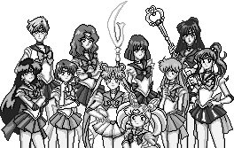
___________________________________________
Great job!

