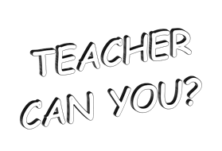
YOUR PICTURE OR A CLIP ART PICTURE GOES HERE!
No, I can’t.
Can you eat sushi?
Can you play tennis?
Name: __________________ Class: ___ Number: ___ Date: __ / __
Yes, I can.

例:He can’t eat sushi. X He can play tennis. O
ALT
JTE
- __________________________________ 0  - __________________________________ X  - __________________________________ 0  - __________________________________ X  - __________________________________ 0 | - __________________________________ 0  - __________________________________ X  - __________________________________ 0  - __________________________________ X  - __________________________________ 0

- __________________________________ 0  - __________________________________ X  - __________________________________ 0  - __________________________________ X  - _______________________________ 0 | - __________________________________ 0  - __________________________________ X  - __________________________________ 0  - __________________________________ X  - ________________________________ 0

