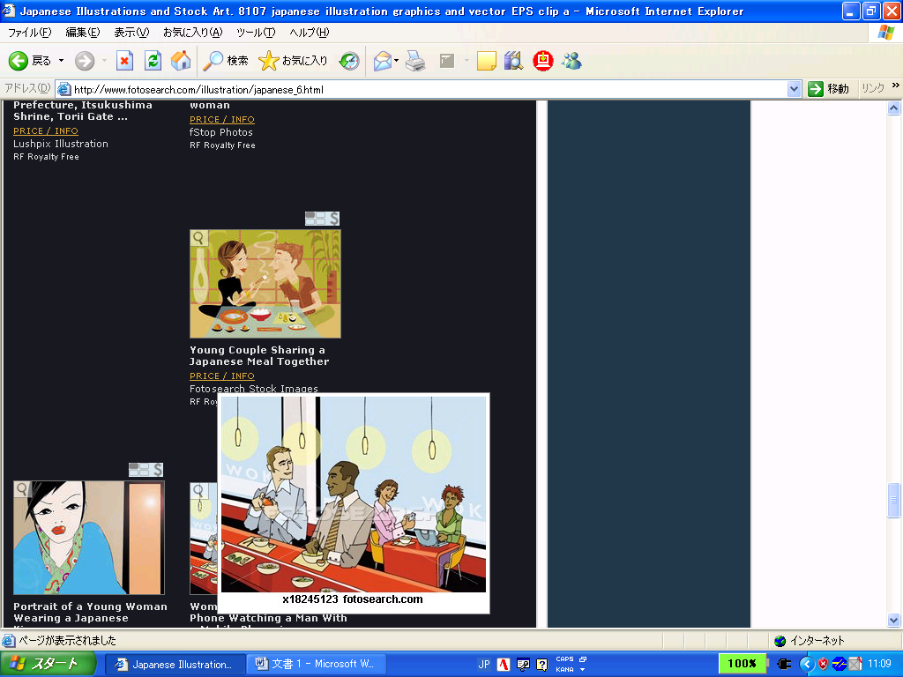

Do you know how to……… Interview!

Yes, I do.

Do you know how to use chopsticks?

Yes, I do. No, I don’t.



|  |  |  |  |
| --- | --- | --- | --- |
| Kanji - Smith's School of Englishwrite kanji? | Cooking Curry clipart. Free download transparent .PNG | Creazillacook curry? | Kids Playing Basketball Vector Art, Icons, and Graphics for Free Downloadplay basketball? | Man is Using ATM clipart. Free download transparent .PNG | Creazillause an ATM? |
|  |  |  |  |
| In Line Skating Clipart Download - Line Skate Clipart - Free Transparent  PNG Clipart Images Downloadskate? | C:\Users\9712647\AppData\Local\Microsoft\Windows\INetCache\Content.MSO\293BD897.tmpspeak Sendai-ben? | Free Car Driving Clipart, Download Free Car Driving Clipart png images,  Free ClipArts on Clipart Librarydrive a car? | Girl is playing piano clipart. Free download transparent .PNG | Creazillaplay the piano? |
|  |  |  |  |
| Riding A Bike Clipart Ideas | Ilustração de bicicleta, Desenho familia,  Desenho de bicicletaride a bicycle? | Boy is Swimming clipart. Free download transparent .PNG | Creazillaswim? | Eating With Chopsticks Clipart, HD Png Download - kindpnguse chopsticks? | dance clipart - Clip Art Librarydance? |
|  |  |  |  |
| Student Using Smartphone During Class Royalty Free SVG, Cliparts, Vectors,  And Stock Illustration. Image 71497911.use a smartphone? | Premium Vector | Cute girl painting on canvaspaint? | Woman Decorates A Cake Stock Illustration - Download Image Now - Cake,  Confectioner, Women - iStockbake a cake? | 2,910 Kids Fishing Illustrations & Clip Art - iStockfish? |
|  |  |  |  |

**Write six sentences using the information from the table.**

Example: Kaito **knows how to** write kanji.

Kaito **doesn’t know how to** write kanji.

1. ________________________________________________________________________________________________
2. ________________________________________________________________________________________________
3. ________________________________________________________________________________________________