Explore the World

Name:______________ Student Number:_________

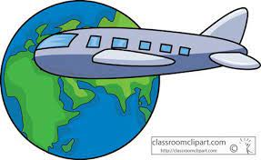
Step 1: Pick a Country

Activity 1: Name as many countries as you can!
Try to get at least one from each continent.

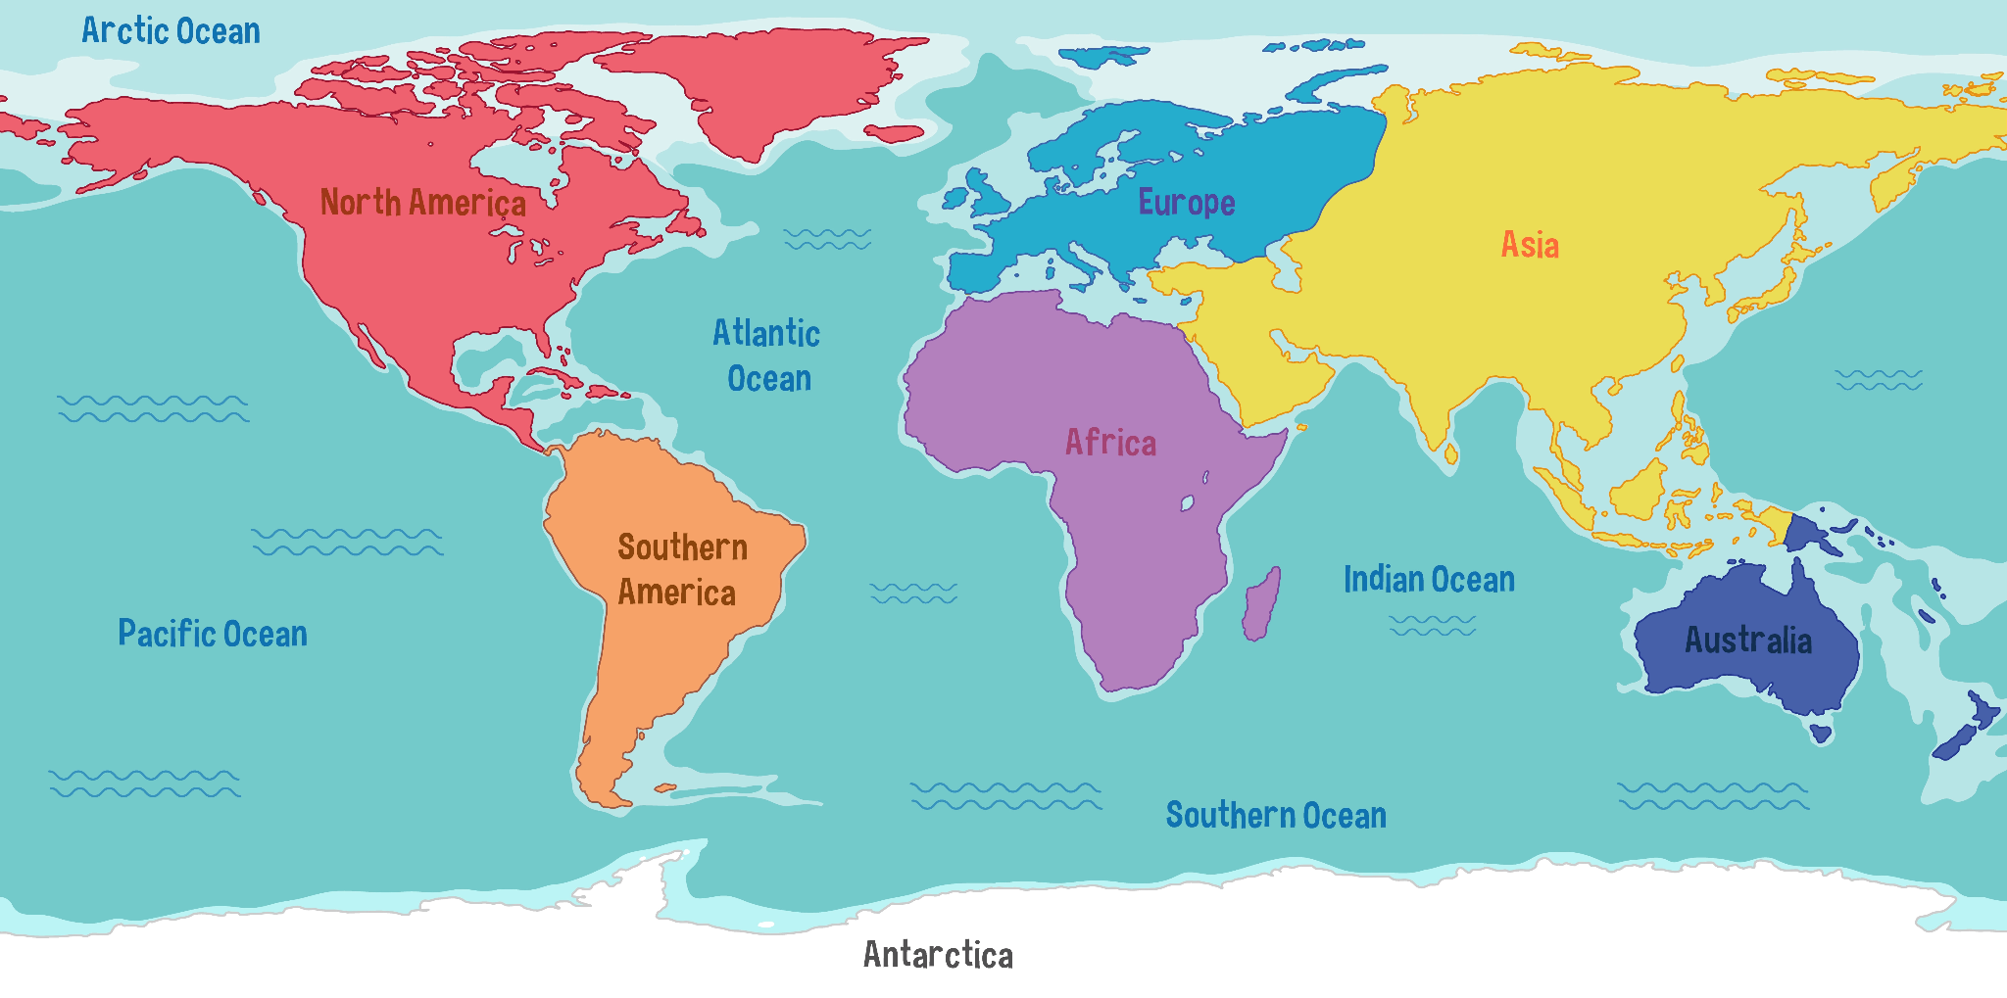

Activity 2: Write down your 3 favorite countries! Do not say Japan or U.S.A.! Then talk in a group and decide which country you will go to.

Country 1:____________________
Country 2:____________________
Country 3:____________________

Group’s Country: ________________

Why do you want to go there?______________________________

Hello! Our names are__________________________.
Step 3: Presentation

Our group decided we want to go to ________________.

Our country has___________________________________.

It_____________________________________________.

One fun fact about our country is ____________________

_______________________. We are very excited to go!

Example:
Sensei and Sensei
Hello! Our names are________________________.
Japan
Our group decided we want to go to _______________.
a Population of 123 Million People
Our country has_____________________________________.
has a Famous Dish called Sushi
It______________________________________________.
Tokyo is the World’s
One fun fact about our country is ______________________
Most Populated City
_______________________. We are very excited to go!

