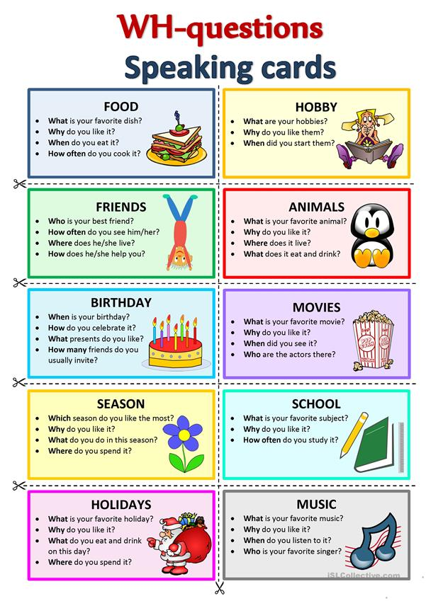

* **Wha**t season do you like?
* **Why** do you like it?
* **What** season do you not like?
* **Wha**t is your hobby?
* **Why** do you like it?
* **Where** do you do it?
* **Wha**t subject do you like?
* **Why** do you like it?
* **When** do you go to school?
* **Where** do you study?
* **Wha**t holiday do you like?
* **What** food do you eat?
* **Where** do you go?
* **When** is it?
* **Wha**t music do you like?
* **Who** is the musician?
* **How** do you listen?
* **Wha**t movie do you like?
* **Why** do you like it?
* **When** do you watch movies?
* **What** actor do you like?
* **When** is your birthday?
* **What** party do you like?
* **Who** comes to the party?
* **What** present do you want?
* **Wha**t animal do you like?
* **Why** do you like it?
* **Where** can you see it?
* **What** can it do?
* **Who** is your best friend?
* **What** do you play together?
* **Where** does he/she live?
* **When** did you meet?
* **Wha**t food do you like?
* **Who** makes it?
* **When** do you eat it?
* **Can** you make it?