AUSTRALIA
CALL ME
CANNOT
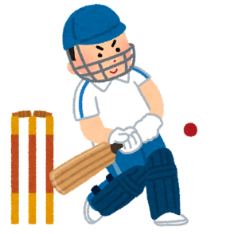
CRICKET
EVERY
FAN
JUST
LITTLE
OFTEN
SYDNEY
THERE
日本語
Unit 1 Vocabulary Search
＿＿＿＿＿
＿＿＿＿＿




