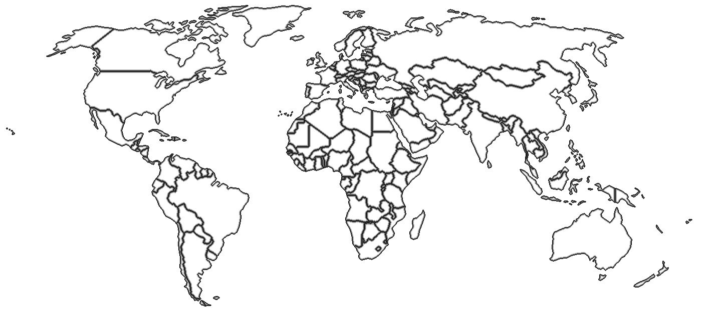Explore the World

Name:______________ Student Number:_________

Country: ____________________

Capital: _____________________

Continent: ___________________

Flag 



Key Sight

____________________________________________________________________________________________________________________________________________________________________________________________________________________________________

Famous Dish:

___________

Population: ___________________

Language: ____________________

Currency: _____________________

Leader: _______________________

Founded





National Animal



2 Fun Facts:

Explore the World

Example

Japan

Country: ____________________

Capital: _____________________

Continent: ___________________

Tokyo

Asia

Flag 



Key Sight

____________________________________________________________________________________________________________________________________________________________________________________________________________________________________

Famous Dish:

___________

Population: ___________________

Language: ____________________

Currency: _____________________

Leader: _______________________

123 Million People

Japanese

The Yen ¥

Prime Minister

Fumio Kishida

Founded





660 BC

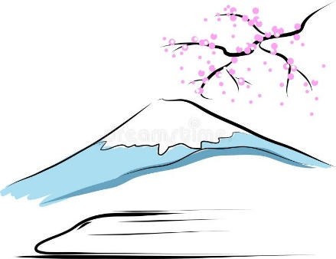

Mt Fuji



National Animal



Macaque Monkeys



* Tokyo is the World's Most Populated City.

2 Fun Facts:

* Japan Has Many Active Volcanoes.

Sushi