Name:____________________ Class: ____ Number: ___

It’s rhyme time
Can you guess the rhyme word?
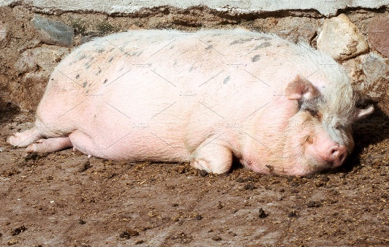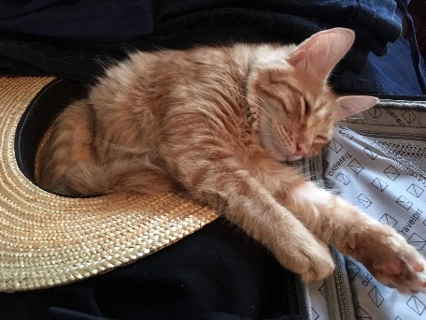
- The __ __ __ pig. 2. __ __ __ in a hat.

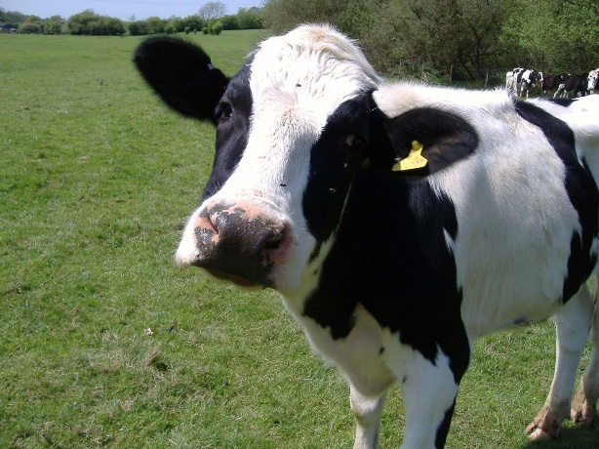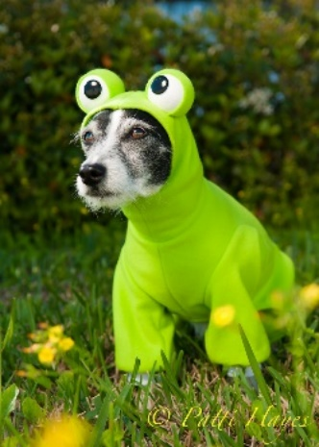
WOW!!
- The __ __ __ says “__ __ __”! 4. __ __ __ __ __ __ __.

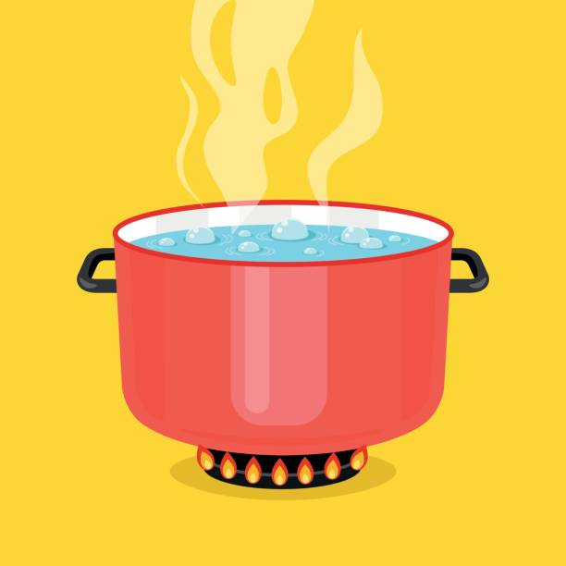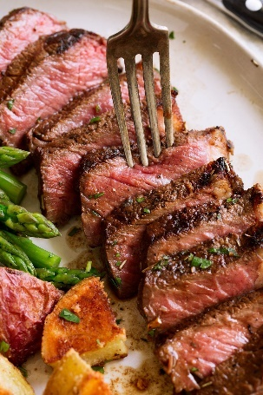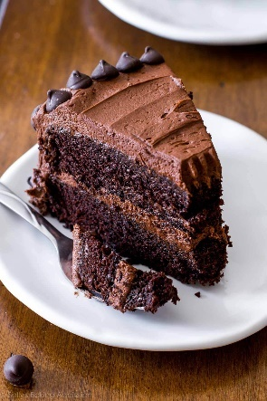
5. The pot is __ __ __. 6. I like __ __ __ __ __
and __ __ __ __.

