America

also

area

around

breakfast

come

cook

crowded

good morning

market

Philippines

picnic

popular

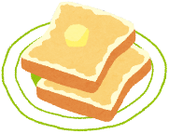symbol

toast

https://1.bp.blogspot.com/-abb3H5nTW7A/VXOT5Js2DeI/AAAAAAAAuE4/-D4TlMMPsX4/s800/machi_line2.pnghttps://1.bp.blogspot.com/-abb3H5nTW7A/VXOT5Js2DeI/AAAAAAAAuE4/-D4TlMMPsX4/s800/machi_line2.pnghttps://1.bp.blogspot.com/-abb3H5nTW7A/VXOT5Js2DeI/AAAAAAAAuE4/-D4TlMMPsX4/s800/machi_line2.pngwow

yogurt

Unit 2 Vocabulary Search

