Name………………… Class ……………… Number ……………
What to and Need
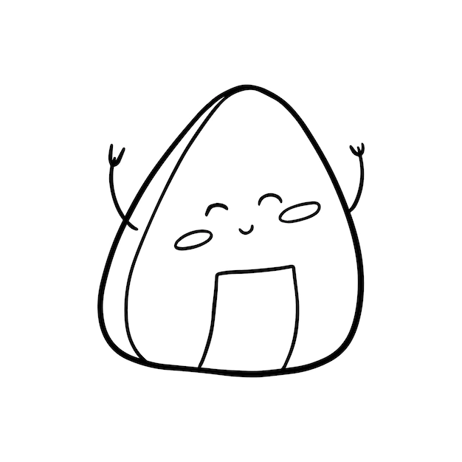
1．( eat an Onigiri) I am a little hungry.
……………………………………………………………………………………
2. (play soccer) They have a soccer ball.
……………………………………………………………………………………
3. (buy an umbrella) It will rain tomorrow.
……………………………………………………………………………………
4. (visit China) You like China.
……………………………………………………………………………………
6. (bring PE clothes) They have PE tomorrow.
……………………………………………………………………………………
7. (drink some water) It is very hot today.
……………………………………………………………………………………
8. (new shoes) Ryo’s shoes are very old.
……………………………………………………………………………………
9. (eat ice-cream) Niki likes ice-cream.
……………………………………………………………………………………
10. (run to school) It is 8:20 AM on Monday. You are at home.
…………………………………………………………………………………….

