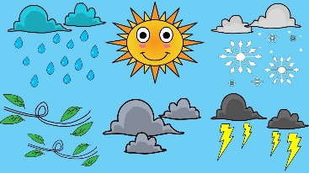
Name: ______________________ Class: ___ Number: ___ Date: ___ /__
How will the weather be on Monday?
It will be hot and sunny.

ROUND ONE

START
GOAL
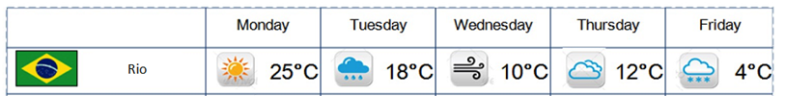
GOAL

ROUND TWO

START

- It will be _______. _____________________________________________________________________
- It will be ________. ____________________________________________________________________
- We will have ____ _____. ________________________________________________________________
- We will go to ________. _________________________________________________________________
- We will meet your ________. _____________________________________________________________
- We will have a _______. _________________________________________________________________
- We will ____ many ____ ____. ____________________________________________________________
- We will have _______ ____. ______________________________________________________________
- It will be ________. ____________________________________________________________________
- It will be _______. ___________________________________________________________________
- We will go to __________. _______________________________________________________________
- Our _____ will be _____, _______________________________________________________________
What will you do this weekend?
____________________________________________________________________________________
____________________________________________________________________________________
____________________________________________________________________________________

- It will be sunny.
- It will be rainy.
- You will have free time.
- You will go to Tokyo.
- You will meet your friends.
- You will have a test.
- You will eat many rice balls.
- You will have 10,000 yen.
- It will be snowy.
- It will be hot.
- You will go to Disneyland.
- Your teacher will be angry.

