ONE | ONE | ONE | ONE | ONE
ONE | ONE | ONE | ONE | ONE
ONE | ONE | ONE | ONE | ONE
ONE | ONE | ONE | ONE | ONE
ONE | ONE | ONE | ONE | ONE
ONE | ONE | ONE | ONE | ONE
Buy  +2 | Buy  +2 | Buy | Buy | Buy
Find  +2 | Find  +2 | Find | Find | Find
Show  +2 | Show  +2 | Show | Show | Show
Give  +2 | Give  +2 | Give | Give | Give
Give | Show | Buy | Find | Buy Show  WILD  Give Find
Buy Show  WILD  Give Find | Buy Show  WILD  Give Find | Buy Show  WILD  Give Find | Buy Show  WILD  Give Find | Buy Show  WILD  Give Find
ONE | ONE | ONE | ONE | ONE
ONE | ONE | ONE | ONE | ONE
ONE | ONE | ONE | ONE | ONE
ONE | ONE | ONE | ONE | ONE
ONE | ONE | ONE | ONE | ONE
ONE | ONE | ONE | ONE | ONE
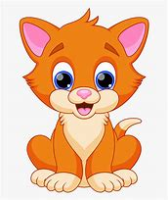  Find | Find | Find | 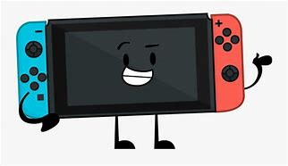  Find | Find
Find | 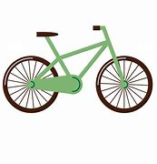  Find | Find | Find | 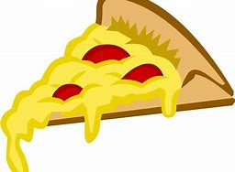  Find
Find | Find | 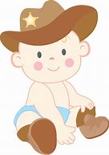  Find | Find | Find
Buy | Buy | Buy | Buy | Buy
Buy | Buy | Buy | Buy | Buy
Buy | Buy | Buy | Buy | Buy
ONE | ONE | ONE | ONE | ONE
ONE | ONE | ONE | ONE | ONE
ONE | ONE | ONE | ONE | ONE
ONE | ONE | ONE | ONE | ONE
ONE | ONE | ONE | ONE | ONE
ONE | ONE | ONE | ONE | ONE
Show | Show | Show | Show | Show
Show | Show | Show | Show | Show
Show | Show | Show | Show | Show
Give | Give | Give | Give | Give
Give | Give | Give | Give | Give
Give | Give | Give | Give | Give

