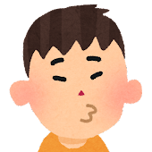
Why Don’t You…

Write an answer for each problem!

I’m hungry! ================= Why don’t you eat some food?

I’m sleepy! ================= Why don’t you go to bed?

I’m bored! Why don’t you…

I’m sad!

I have a toothache!

I’m wet!

I’m uncomfortable!

I have a test tomorrow!

I’m cold!

I’m too hot!
Toothache = 歯痛

Uncomfortable = 気詰まり

Too hot = 暑すぎる

Bored = 所在なげ

