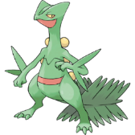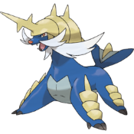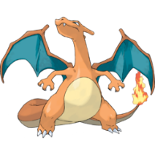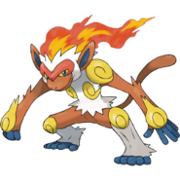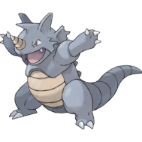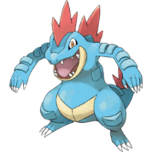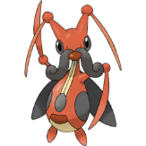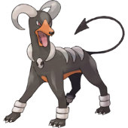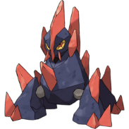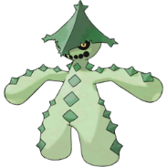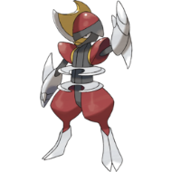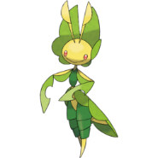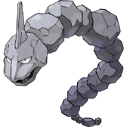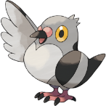

Ancient Greek: Big / Rock

Chess piece

Another name for "Yeti"

Raichu

Same as Japanese

Sceptile

Scepter / *Sceptridium*

Scissors/ Reptile

Samurott

Samurai / Otter

Infernape

Inferno / Ape

Charizard

To char / Lizard

Feraligatr

Feral / Alligator

Vanilluxe

Vanilla / Deluxe

Sudowoodo

Pseudo / Wood

Scrafty

Scrappy / Crafty

Rhydon

Rhino/Rhyolite/*don*

Krookodile

Crook / Crocodile

Kricketune

Cricket / Tune

Houndoom

Hound / Doom

Gigalith

*Gigas* / *Lithos*

Chandelure

Chandelier / Lure

Cacturne

Cactus / Nocturnal

Bisharp

Bishop / Sharp

Abomasnow

Abominable Snowman

Leavanny

Leaves / nanny

Onix - Onyx

Pidove

Pigeon / Dove