NAME ____________________________________ CLASS ____________

Description: C:\Documents and Settings\t27\Local Settings\Temporary Internet Files\Content.IE5\69AN8HUT\MC900241151[1].wmf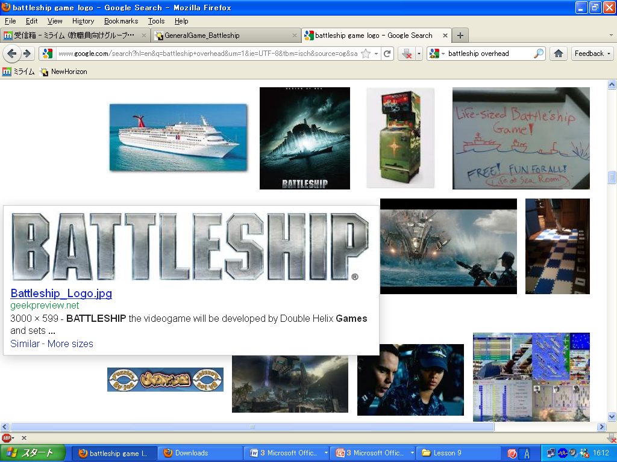Description: C:\Documents and Settings\t27\Local Settings\Temporary Internet Files\Content.IE5\69AN8HUT\MC900241151[1].wmf

**Q:** Can I have a ________ and ________?

**A:**  Yes, Here you are. /  No, sorry.

|  |  |  |
| --- | --- | --- |
| HOME |  | TARGET |
| Place 3 ships unnamed (1).png unnamed (1).png unnamed (1).png |  | Hit = **O** Miss = **X** |

- - - - - - - - - - - - - - - - - - - - - - - - - - - - - - - - - - - - - - - - - - - - - - - - - - - - - - - - - - - - - - - - - - - - - - - - - - - - - - - - - - - - - - - - - - - - - - - - - - - - - - - - - - - - - - - - - - - - - - - - - - - - - - - - - - - - - - - - - - - - - -

|  |  |  |  |  |  |  |  |  |  |  |  |  |  |
| --- | --- | --- | --- | --- | --- | --- | --- | --- | --- | --- | --- | --- | --- |
|  | preview16.jpg | preview16.jpg | preview16.jpg | preview16.jpg | preview16.jpg |  |  |  | preview16.jpg | preview16.jpg | preview16.jpg | preview16.jpg | preview16.jpg |
| preview16.jpg |  |  |  |  |  |  |  | preview16.jpg |  |  |  |  |  |
| preview16.jpg |  |  |  |  |  |  |  | preview16.jpg |  |  |  |  |  |
| preview16.jpg |  |  |  |  |  |  |  | preview16.jpg |  |  |  |  |  |
| preview16.jpg |  |  |  |  |  |  |  | preview16.jpg |  |  |  |  |  |
| preview16.jpg |  |  |  |  |  |  |  | preview16.jpg |  |  |  |  |  |