Spring Vacation
Write your answer and interview your partner.

- How was your spring vacation?

It was (interesting/ exciting /scary / fantastic / beautiful / boring).

- Did you go anywhere? Yes, I did. No, I didn’t.

Where did you go? I went to _________________.

- Did you buy anything? Yes, I did. No, I didn’t.

What did you buy? I bought __________________.

- Did you watch any movies? Yes, I did. No, I didn’t.

What did you watch? I watched _________________.

- Did you read any books? Yes, I did. No, I didn’t.

What book did you read? I read ___________________.

- Did you see anyone? Yes, I did. No, I didn’t.
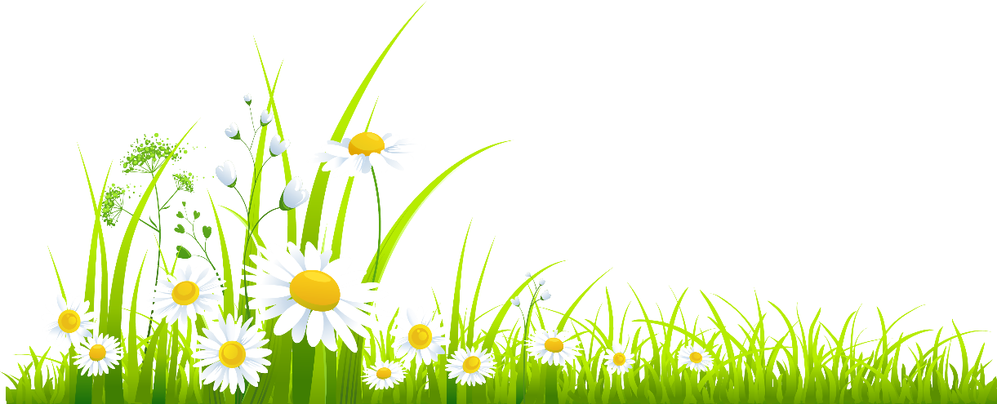
Who did you see? I saw ___________________.

