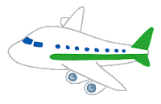Plan a Holiday

Name: ____________________

**2.What’s the currency?**

The currency is

_______________.

**1.Where are you going?**

We’re going to

______________________

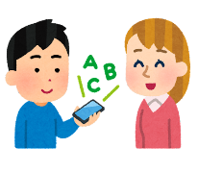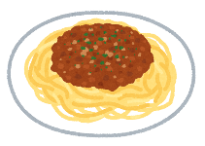

**6.Draw the flag:**

**4.What is a special dish there?**

A special dish in ___________

is ________________.

It’s________________________________________

_____________________________

**5.What can you do there?**

1. You can **__________________________________**
2. You can **_________________________________**
3. You can **__________________________________**
4. You can **__________________________________**

**3.What language do they speak?**

They speak______________

in __________________