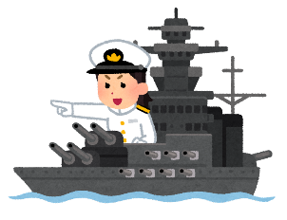
BATTLESHIPS
Opponent’s Ships
 |  | When you’re _____,
 |  | free | sad | angry | nervous | happy | tired | bored
do you _______? | play sport
 | listen to music
 | read manga
 | take a bath
 | watch funny videos
 | hang out with friends
 | draw

Your Ships
 |  | When you’re _____,
 |  | free | sad | angry | nervous | happy | tired | bored
do you _______? | play sport
 | listen to music
 | read manga
 | take a bath
 | watch funny videos
 | hang out with friends
 | draw
Ships
⃝ Yes = “Hit” 打つ
✖ No = “Miss” 打たない

- = Submarine
- 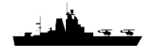 = Cruiser
- 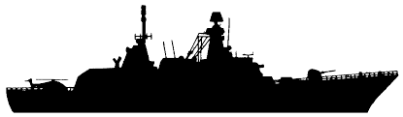 = Destroyer

