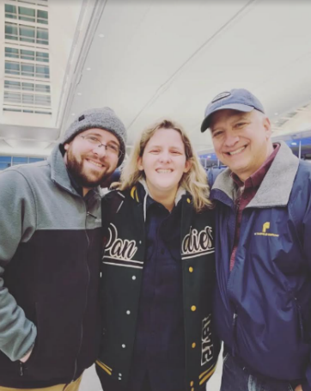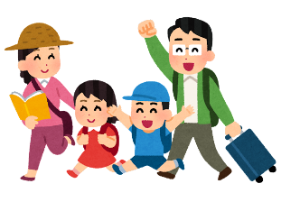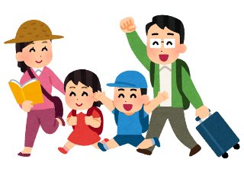ドレスを着て立っている男性たち

中程度の精度で自動的に生成された説明ドレスを着て立っている男性たち

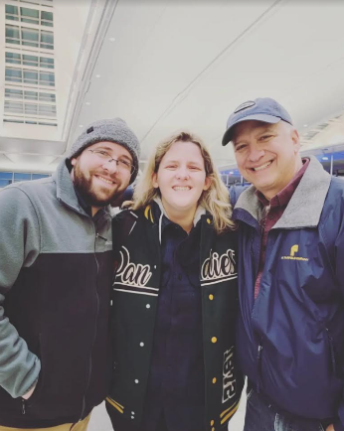

Hello everyone!  
My brother and dad are visiting Japan.   
They will come to Seitoku JHS for one day.  
They are happy to meet you!  
**Please write two questions to ask them.**

Hello everyone!  
My brother and dad are visiting Japan.   
They will come to Seitoku JHS for one day.  
They are happy to meet you!  
**Please write two questions to ask them.**

**Let’s Interview!**

**Let’s Interview!**

My name is:______________________ I’m from class: ____-____

*Examples: What/Who is your favorite ____? Do you like ___? Which do you like better, ___ or ___?*

*Can you _____? What do you want to do in Japan? What do you think about ____? ETC…*どんな質問でも大丈夫です!  
Question #1:  
_______________________________________________________________________________

Question #2:  
_______________________________________________________________________________

My name is:______________________ I’m from class: ____-____

*Examples: What/Who is your favorite ____? Do you like ___? Which do you like better, ___ or ___?*

*Can you _____? What do you want to do in Japan? What do you think about ____? ETC…*どんな質問でも大丈夫です!  
Question #1:  
_______________________________________________________________________________

Question #2:  
_______________________________________________________________________________