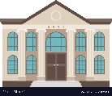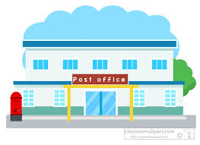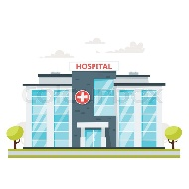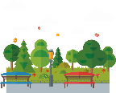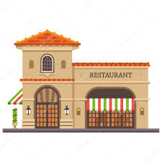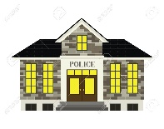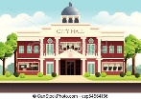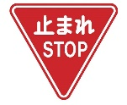000

Go to the police station.

Go back 1 space.

**Shin-Machi Station**

Get off at the Shin- Machi Station.

Get off at the Hon- Machi Station.

Change to the Blue Line.

**School**

Go ahead 2 spaces.

Go ahead 1 space

Change to the Purple Line.

Change to the Orange Line.

Go to the school.

Go to the restaurant

Flip a coin-

Heads- Take the Red Line.

Tails- Take the Blue Line.

Flip a coin-

Heads- Take the Bus Line.

Tails- Take the Orange Line.

Flip a coin-

Heads- Take the Green Line.

Tails- Take the Purple Line.

Get off at the Kita Station.

Take the Train Game

Go to the hospital.

Go to the post office

Go to the city hall.

**Hospital**

**Post Office**

**Bank**

**Higashi Station**

Get off at the Higashi Station.

Change to the Red Line.

Change to the Bus Line.

Change to the Green Line.

Get off at Minami Station.

Go back 1 space.

Go ahead 3 spaces

Go ahead 1 space

**Kita Station**

Go back 1 space.

Go back 1 space.

Go to the bank.

Go ahead 1 space.

**Library**

**Purple Line**

Get off at the Chuo Station.

**Green Line**

**Park**

**Restaurant**

**Bus Line**

**Red Line**

**OrangeLine**

**City Hall**

**Police**

Go ahead 1 space.

**Blue Line**

Go to the park.

**Chuo Station**

**Hon-Machi Station**

Go to the library.

**Start**

Go back 1 space.

**Minami Station**

Go ahead 2 spaces.

**End**