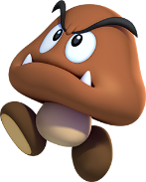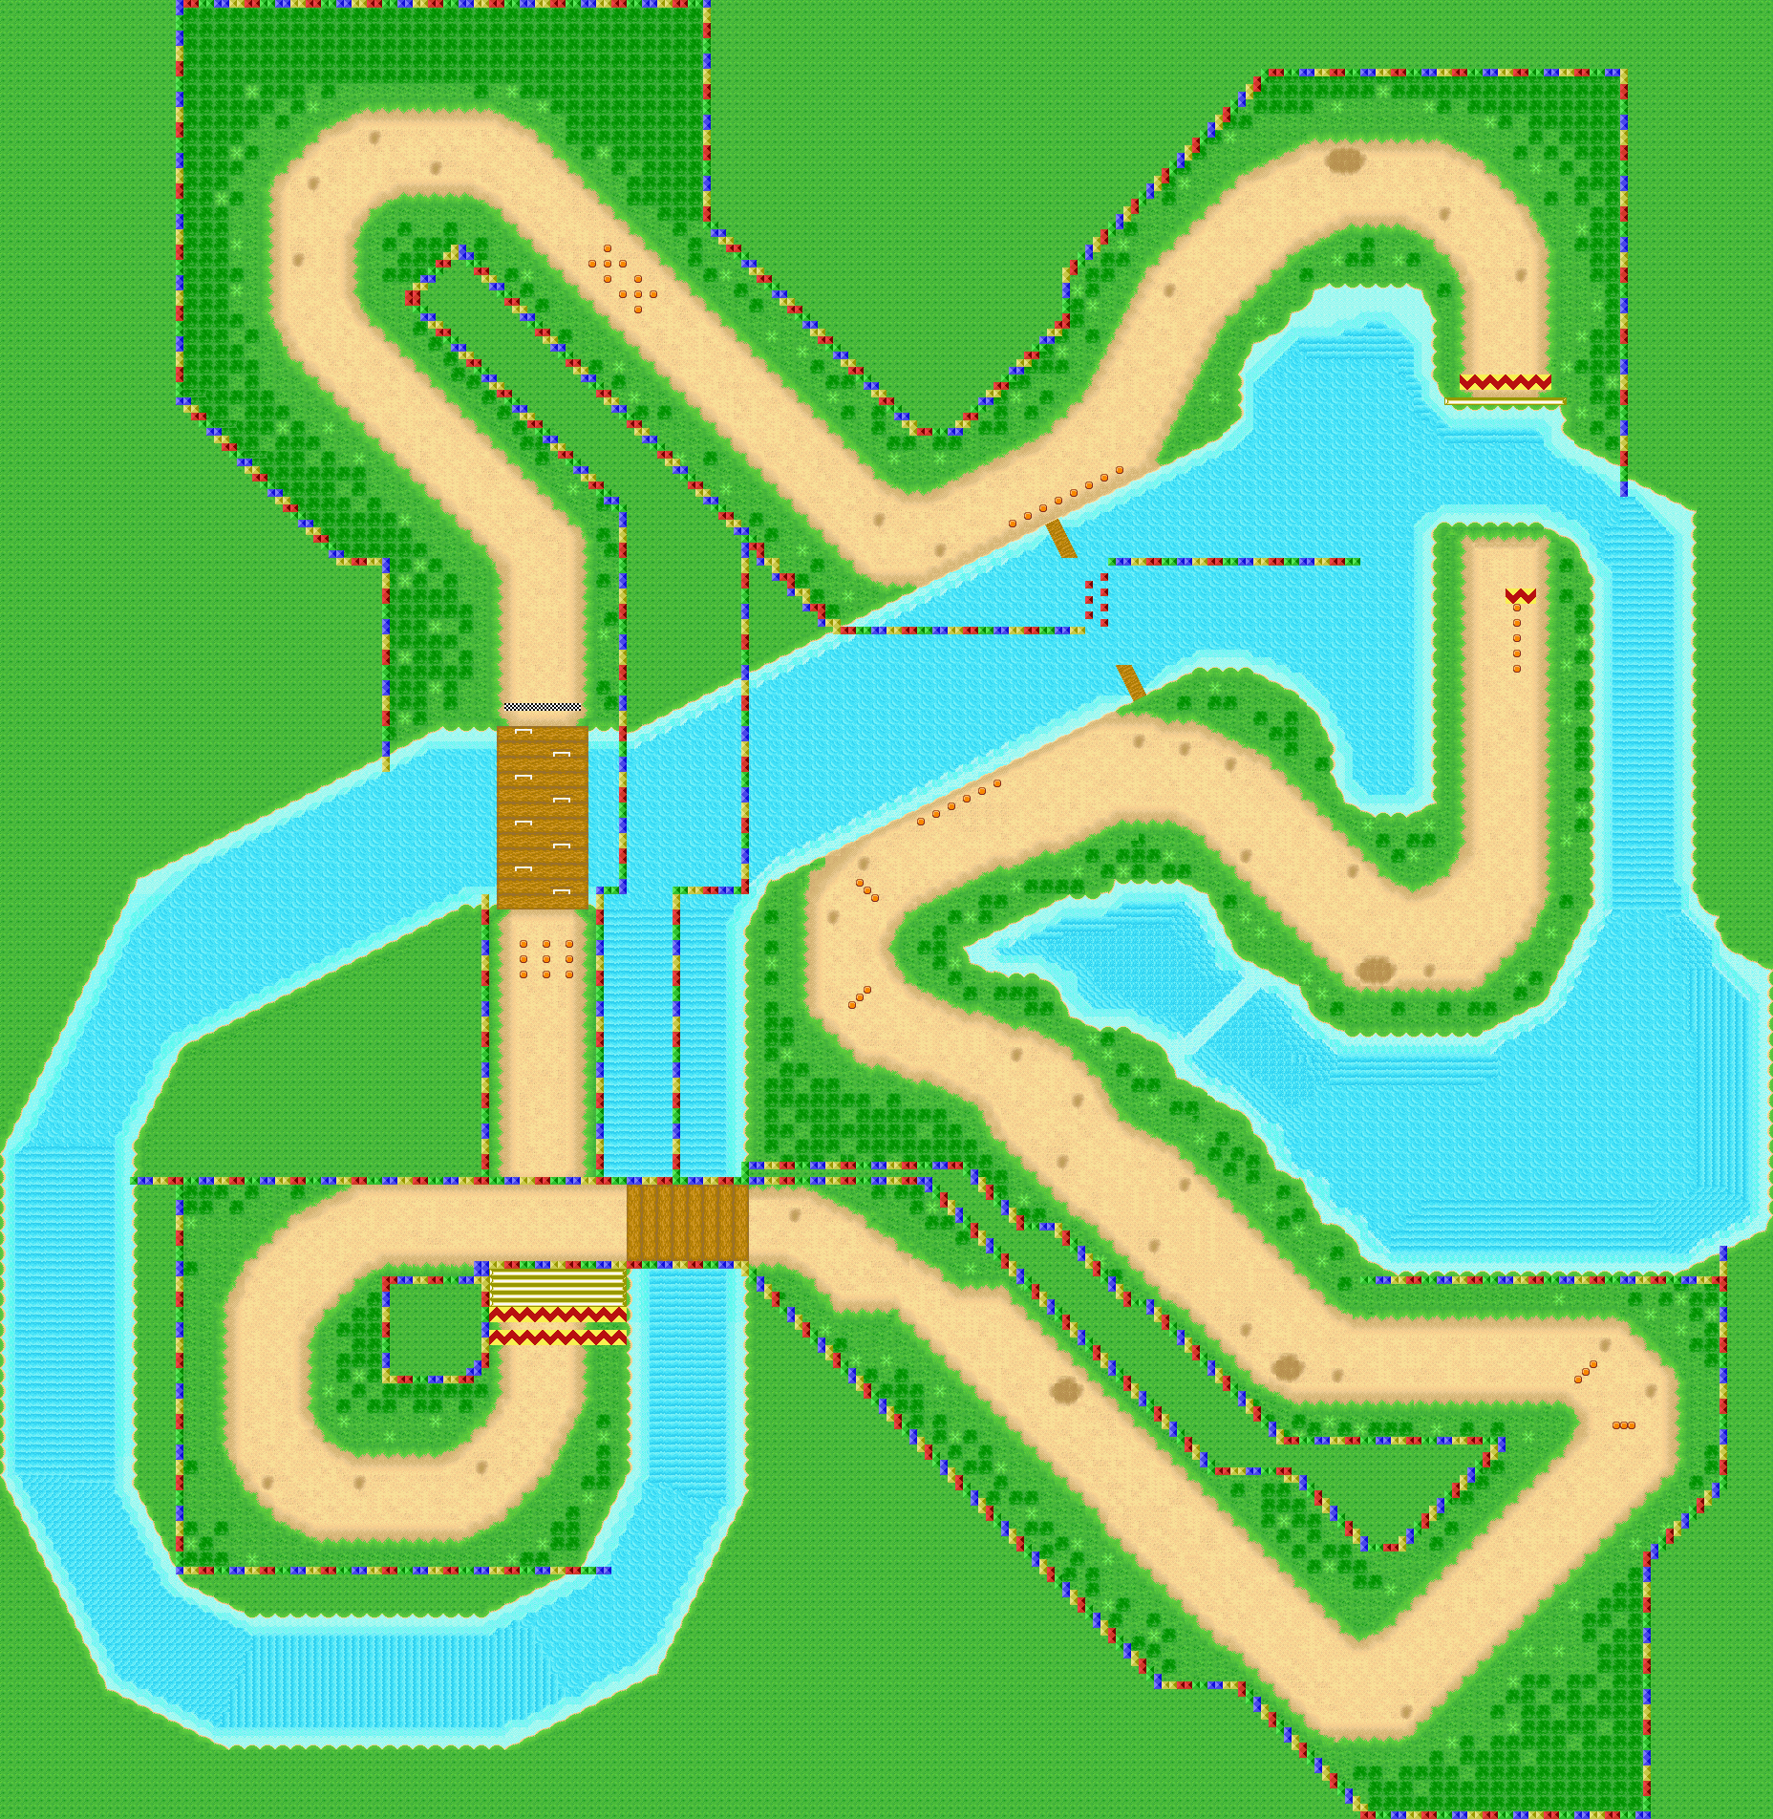

-3 spaces

+3 spaces

Answer a question then roll the dice!

+5 spaces

+2 spaces

-2 spaces

**Draw a card!**

2

2

2

2

2

2

2

2

2

2

2

2

2

2

2

2

2

2

2

2

2

2

2

2

2

2

2

2

2

2

2

2

2

2

2

2

2

2

2

2

2