Name: _____________ number: ____ Class: ___
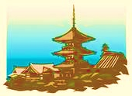
Kyoto Invasion

- ___________ is ________ by _____ ________.
_____________________________________ (+1 point)
- _________ is ______ ____ the _______ there.
_____________________________________ (+1 point)
- ________ movies ____ ______ there.
_____________________________________ (+1 point)
- ________ are _____ by _________.
_____________________________________ (+1 point)
- ______ are _____ ___ the garden.
_____________________________________ (+1 point)
- Kyoto Tower ___ _______ ___ _______..
_____________________________________ (+1 point)
- __________ was ______ ___ _______________.
_____________________________________ (+1 point)
- Many ______ were _____ when we ____ to Kyoto.
_______________ _____________________ (+1 point)

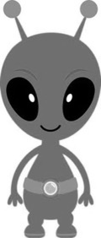
Questions

What did you do during the spring vacation?
________________________________________
________________________________________
What do you want to do this year?
________________________________________
________________________________________
Which do you like better, spring or summer?
________________________________________
________________________________________
Which is more interesting, games or movies?
________________________________________
________________________________________
What do you have to do this year?
________________________________________
________________________________________
What is made in your town?
________________________________________
________________________________________
QUIZ QUESTIONS
What is the longest river in Japan?
What is as white as snow?
Which is faster, light or sound?
What time do you get up?
What sports can you play?
What can a fish do?
What is the highest mountain in Japan?
What is made by Apple?
What is made by SONY?
Who runs the fastest in your class?
Who is the tallest in your class?
Where was pizza first made?
Where is English spoken?
What is spoken in France?
What is eaten in India?
What animals are seen in Australia?
What animals are seen in Africa?
What is made from eggs?
What is cheese made from?
Where are dolphins seen?

