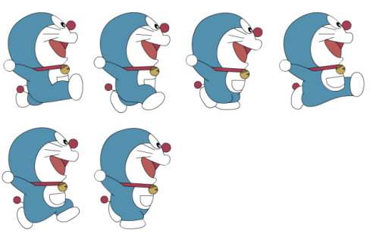***Character Races***

**Name: _________________Class: _______ Number: ____**



***Round One: Unscramble***

**1.**

**2.**

**3.**

**4**.

***Round Two: Fix it***

**5.**

**6.**

**7.**

**8.**

***Round Three: Fill it in***

**9.**

**10.**

**11.**

**12.**