Name: __________________________________

Places in the city

Write the places under the correct picture.

bank city hall hospital museum

school train station bus stop post office

park supermarket convenience store department store

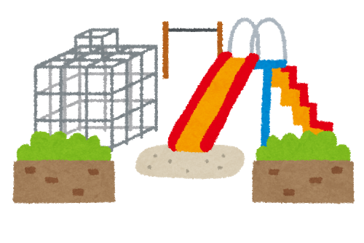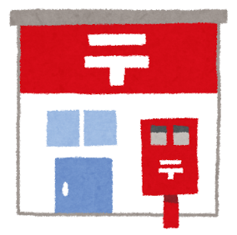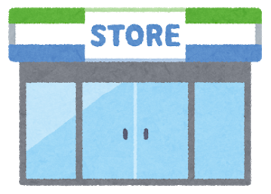1. 2. 3.

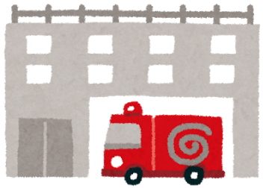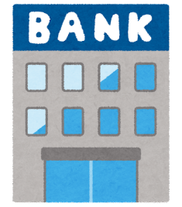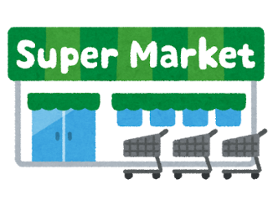

**銀行**

4. 5. 6.

**スパアー**

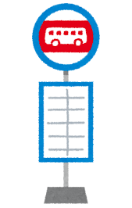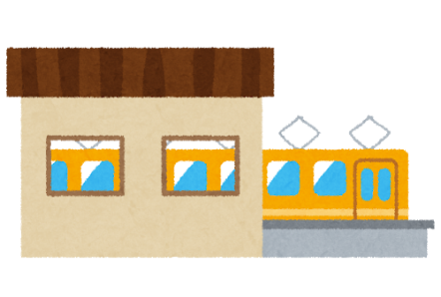

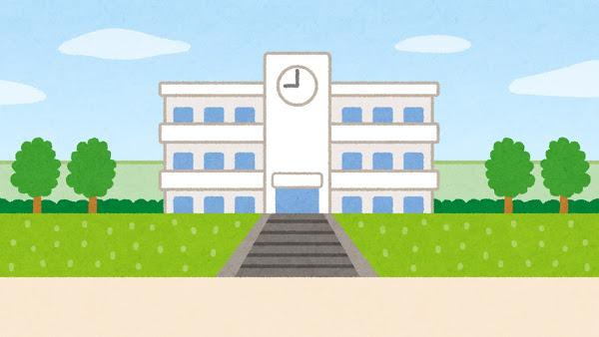7. 8. 9.