NAME:_______________ CLASS:__-__



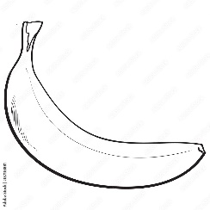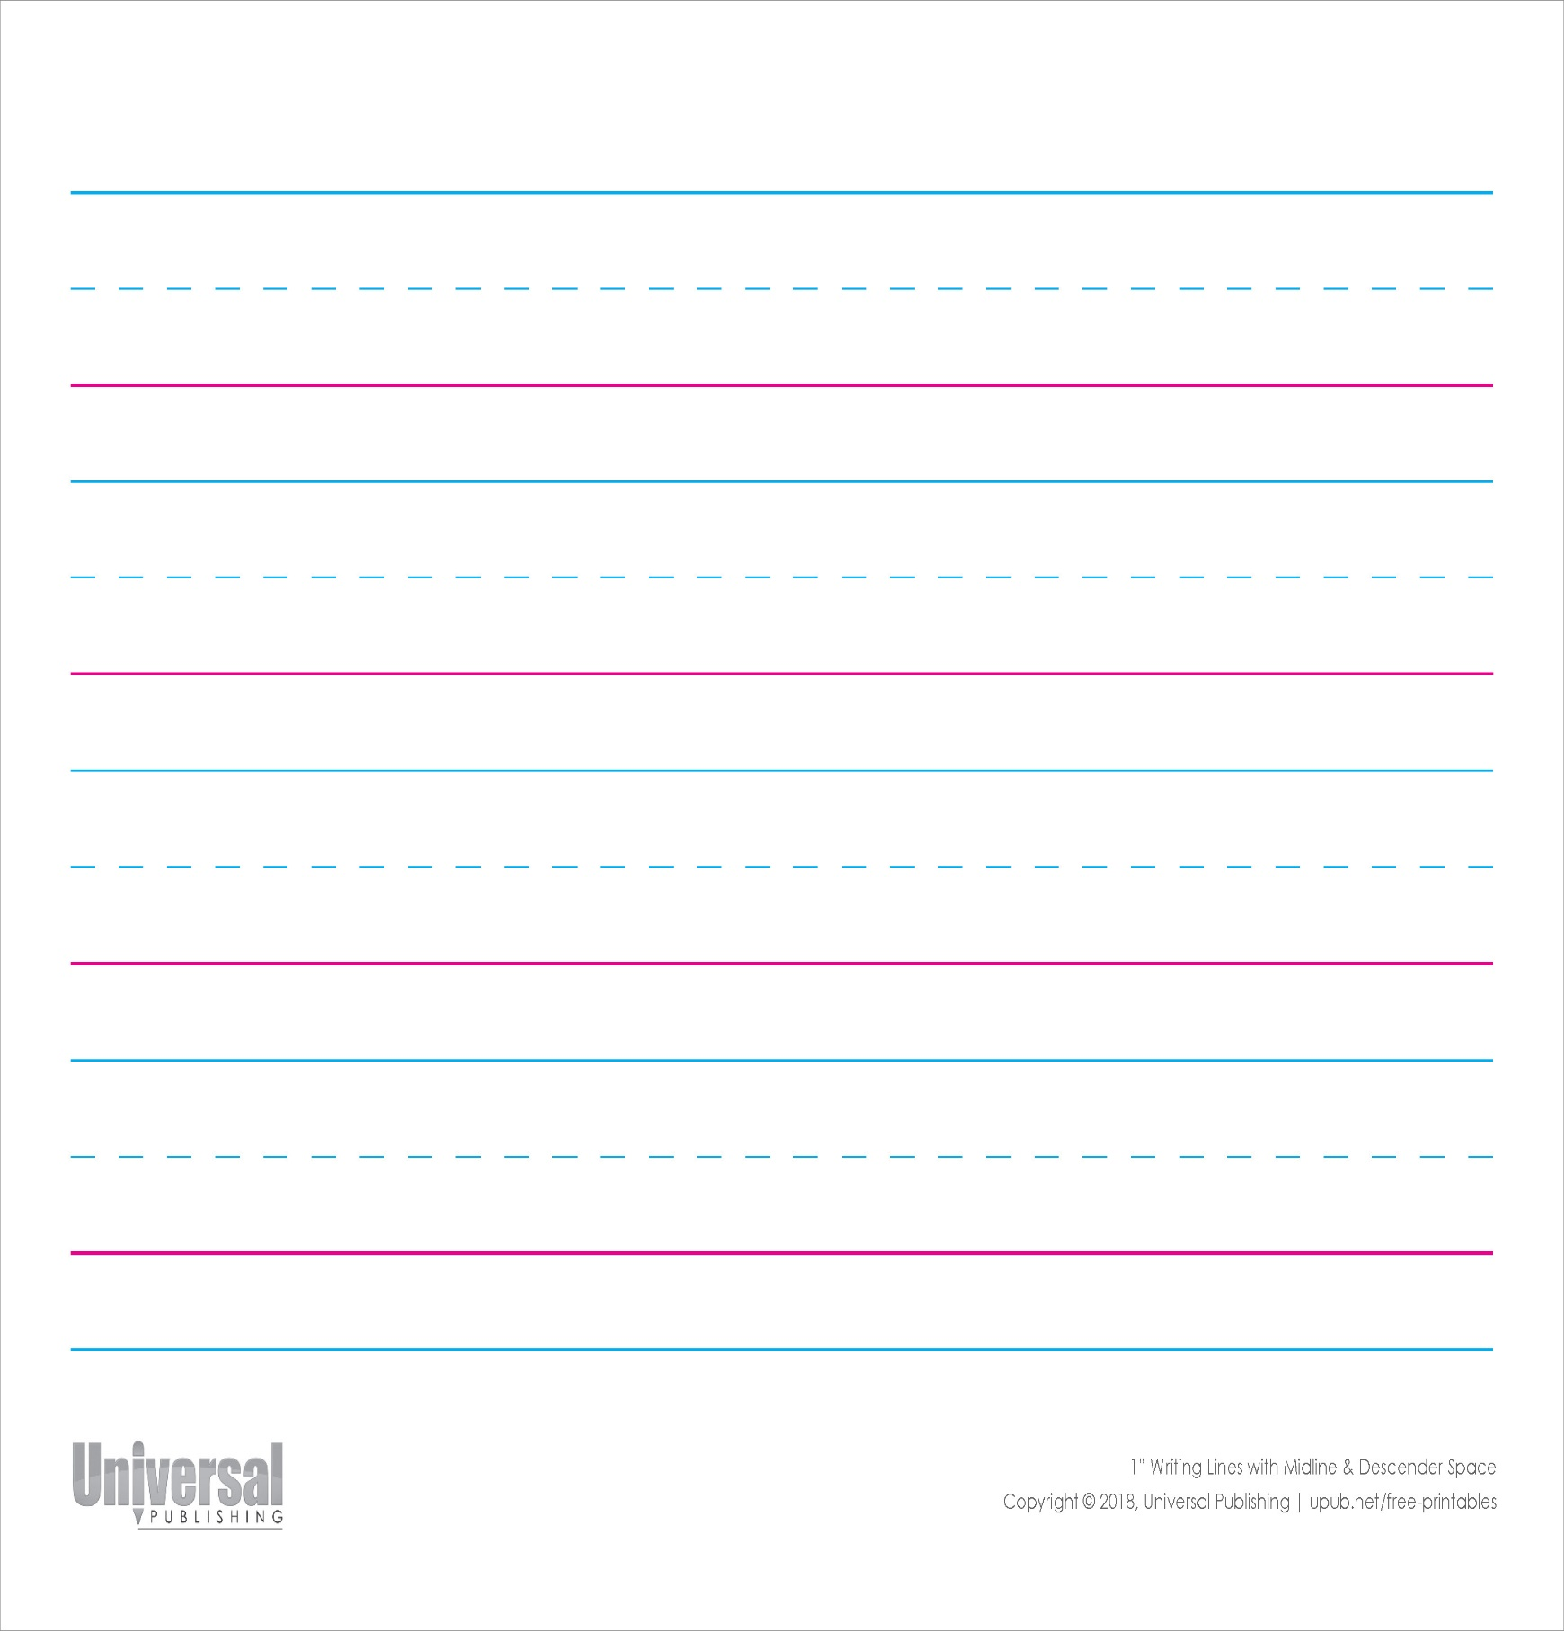

?

?

__AT

__OG

LET’S WRITE!

4

3

2

1

2

1

1

2

1

B

3

2

1

D

A

C

E