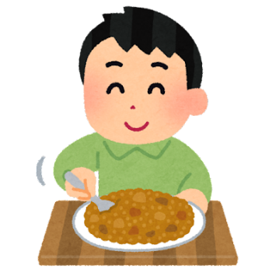
Present your curry!
- My name is _______________.
- This is my curry. It’s called the ________________ curry.
- The ingredients are _____________________________________.
Name | Comment
_______________ | ____________________________________________
_______________ | ____________________________________________
_______________ | ____________________________________________
_______________ | ____________________________________________
_______________ | ____________________________________________
_______________ | ____________________________________________
_______________ | ____________________________________________
_______________ | ____________________________________________
_______________ | ____________________________________________
_______________ | ____________________________________________
_______________ | ____________________________________________
_______________ | ____________________________________________
_______________ | ____________________________________________
_______________ | ____________________________________________
_______________ | ____________________________________________
Thank you for listening.

