how to make okonomiyaki?  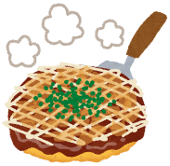  name: ____________ | how to play the piano?  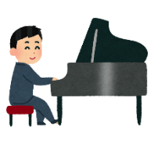  name: ____________ | what to write in a birthday card?  name: ____________
who to ask for help in English class?  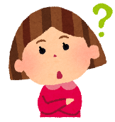  name: ____________ | where to go in an emergency?  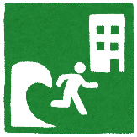  name: ____________ | what to wear at school?  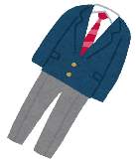  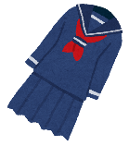  name: ____________
where to buy a Halloween costume?  name: ____________  j | what to do to be healthy?  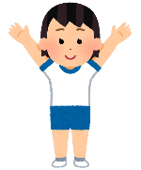  name: ____________ | where to buy German bread in Otsuka?  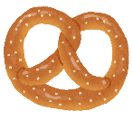  name: ____________
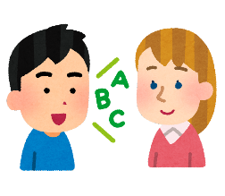  how to say “経験” in English?  name: ____________  j | 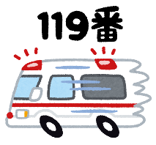  who to call in an emergency?  name: ____________  j | how to bake bread?  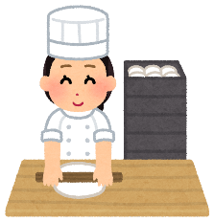  name: ____________  j
Do you know…
Yes, I do. I know…. / No, I don’t. I don’t know….
how to make okonomiyaki?  name: ____________ | how to play the piano?  name: ____________ | what to write in a birthday card?  name: ____________
who to ask for help in English class?  name: ____________ | where to go in an emergency?  name: ____________ | what to wear at school?  name: ____________
where to buy a Halloween costume?  name: ____________  j | what to do to be healthy?  name: ____________ | where to buy German bread in Otsuka?  name: ____________
how to say “経験” in English?  name: ____________  j | who to call in an emergency?  name: ____________  j | how to bake bread?  name: ____________  j
Do you know…
Yes, I do. I know…. / No, I don’t. I don’t know….

