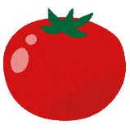  tomato | 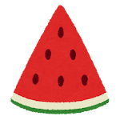  watermelon | 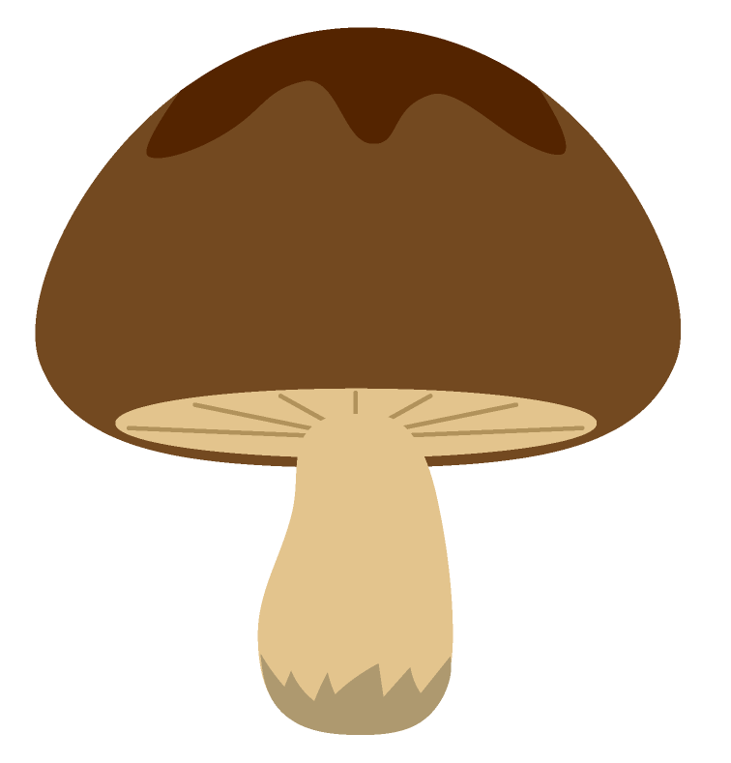  mushroom | strawberry | 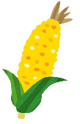  corn
cabbage | 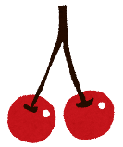  cherry | 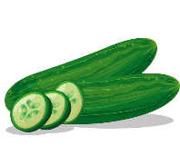  cucumber | 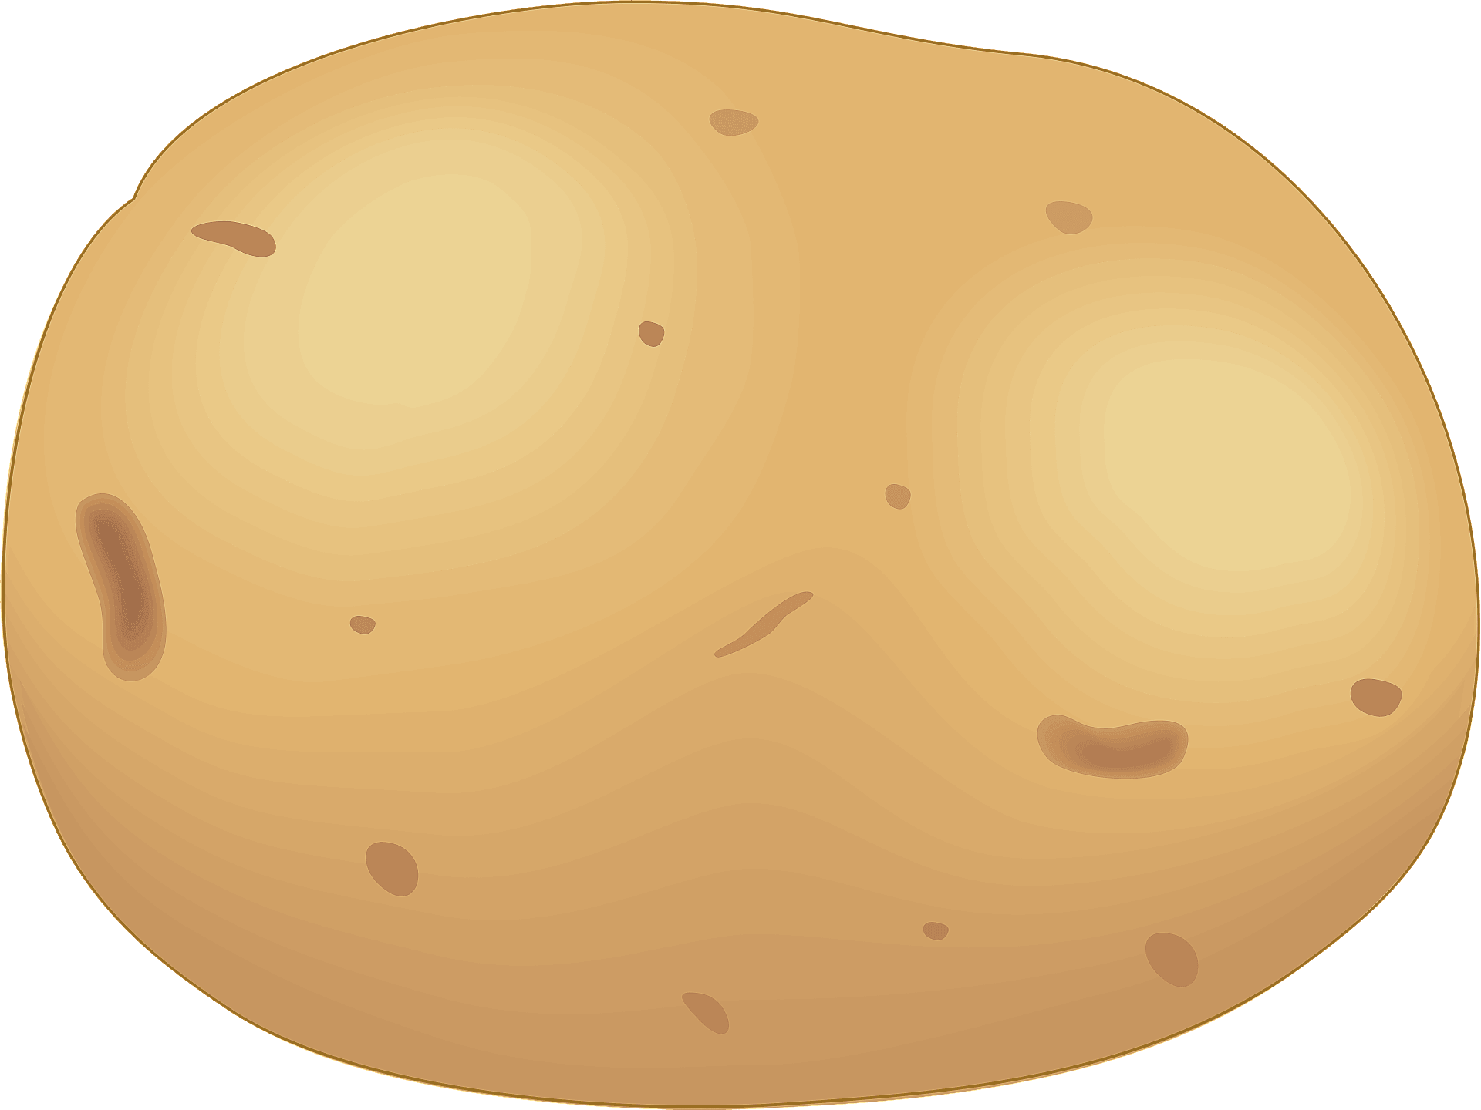  potato | 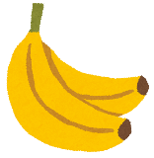  banana
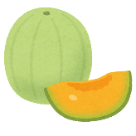  melon | lemon | FREE | 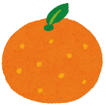  orange | 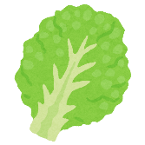  lettuce
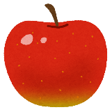  apple | 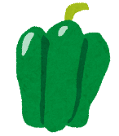  green pepper | 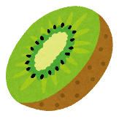  kiwi | 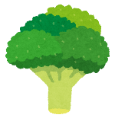  broccoli | grape
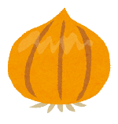  onion | 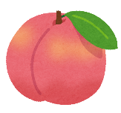  peach | carrot | 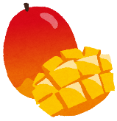  mango | pineapple

broccoli | corn | potato | apple | mushroom
watermelon | strawberry | lettuce | cucumber | orange
melon | kiwi | FREE | banana | onion
cherry | mango | grape | tomato | cabbage
lemon | green pepper | pineapple | peach | carrot

mango | onion | melon | orange | green pepper
cabbage | cucumber | strawberry | lemon | carrot
mushroom | potato | FREE | grape | peach
Kiwi | pineapple | lettuce | watermelon | corn
broccoli | apple | cherry | tomato | banana

cucumber | grape | lettuce | corn | mango
Onion | broccoli | carrot | peach | strawberry
potato | melon | FREE | cherry | Tomato
Banana | mushroom | apple | green pepper | kiwi
orange | watermelon | pineapple | lemon | cabbage

onion | cabbage | peach | grape | Melon
cherry | pineapple | lemon | apple | tomato
orange | carrot | FREE | mango | mushroom
kiwi | corn | banana | lettuce | cucumber
watermelon | broccoli | green pepper | potato | strawberry

carrot | potato | mango | lettuce | strawberry
green pepper | tomato | mushroom | pineapple | apple
peach | banana | FREE | watermelon | broccoli
grape | corn | kiwi | melon | onion
cherry | orange | cucumber | cabbage | lemon

corn | banana | cherry | kiwi | tomato
lemon | peach | pineapple | mango | melon
orange | watermelon | FREE | lettuce | green pepper
Grape | onion | cabbage | apple | potato
carrot | mushroom | strawberry | cucumber | broccoli

kiwi | banana | green pepper | orange | cabbage
apple | cherry | pineapple | carrot | watermelon
corn | potato | FREE | cucumber | broccoli
peach | mushroom | grape | lemon | melon
mango | lettuce | tomato | onion | strawberry

