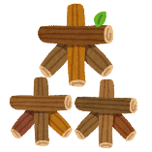
Forest Jeopardy!
Which one? 正しい言葉を選びなさい
Let me _________ _____ __________ for you.
10
She ___________ _____ _________ the books.
20
_____ _________ ______ ______ _______ games last night.
30
______ helped ______ ______________ the ________.
40
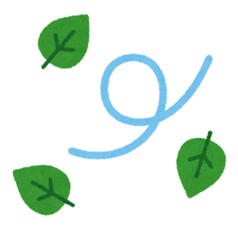
Change to English 日本語から英語に翻訳
I __________ him __________.
10
The _________ ___________ _____ study.
20
______ _______ me ______ _____ the ____________.
30
__________ ______ _____ ______ ______ pen.
40
Change to Japanese 英語から日本語に翻訳
私にドアを＿＿＿＿＿＿＿＿＿＿＿。
10
アヤが＿＿＿＿＿の＿＿＿＿＿＿を___________________________________。
20
＿＿＿＿＿は＿＿＿＿＿をRycomに＿＿＿＿＿＿＿＿＿＿。
30
＿＿＿＿＿は__________に＿＿＿＿＿＿を＿＿＿＿＿＿＿＿＿＿。
40
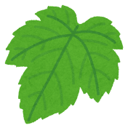
Grammar Mistake 文法間違いを探し＆訂正
Let me _________ ________ my winter vacation.
10
I ________ ______ ______ in the ___________.
30
40
20
Ms. ______ ________ ____ do my ________ ___________ yesterday.
Bob ________ ______ ________ the __________ ____________.

