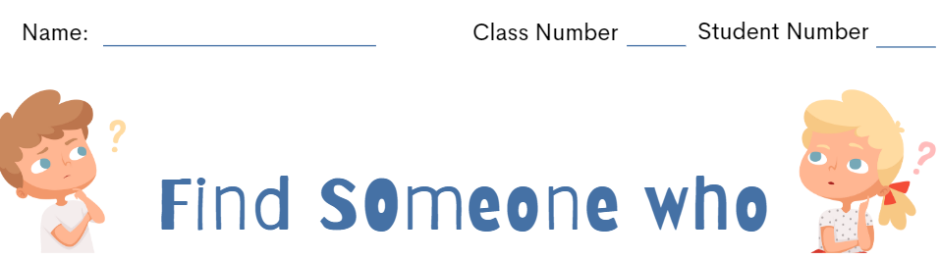
Find a classmate who matches each description. Write his/her name in the box.
Ask your classmate the questions.
Answer “Yes, I do.” or “No, I don’t.” If they answer “Yes, I do”, write their name in the box.

Do you drink coffee every morning?  ______ is someone who is drinking coffee every morning | Do you have TikTok?  _______ is someone who has TikTok | Do you hate spiders?  _______ is someone who hates spiders | Do you have a dog as a pet?  _______ is someone who has a dog as a pet | Do you have a sister?  ________is someone who has a sister
Do you love travelling?  ________ is someone who loves travelling | Do you love cake?  ________ is someone who loves cakes | Do you love reading?  ________ is someone who loves reading | Do you love music?  _______ is  someone who loves music | Do you like cycling?  ______ is someone who likes cycling
Do you play the guitar?  _____ is someone who plays the guitar | Do you speak two languages?  _______ is someone who speaks two languages | Do you play video games at night?  ________ is someone who plays video games at night | Do you eat bread every morning?  ______ is  someone who eats bread every morning | Do you like math  _______ is someone who likes math
Do you like sports?  _______ is someone who likes sports | Do you love broccoli?  _______ is someone who loves broccoli | Do you love chicken?  _______ is someone who loves chicken | Do you walk to school?  _______is someone who walks to school | Do you love summer?  _______is someone who loves summer
Do you like anime?  _______is someone who likes anime | Do you have a brother?  _______is someone who has a brother | Do you know how to whistle?  _______is someone who knows how to whistle | Do you like pizza?  _______is someone who likes pizza | Do you like cooking?  _______is someone who likes cooking

