Comparative (as ~ as)
My bag
Your bag

例）My bag is as big as your bag.
Round 1 – Fill in the blanks!

- He is as _________________________ as her.
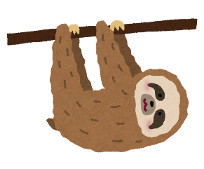

- A sloth is as _________________________ as a snail.
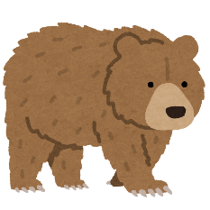
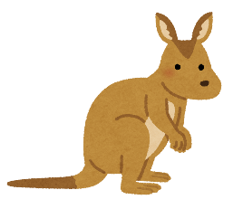

- A bear is as _________________________ as a kangaroo.

- A tablet is as _________________________ as a smartphone.
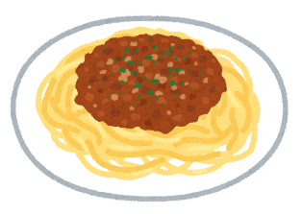

- Pizza is as _________________________ as spaghetti.
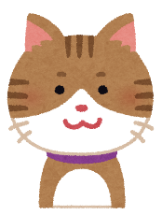
Round 2 – Write the sentence!
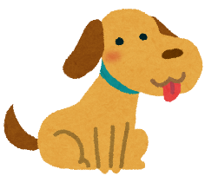
かわいい

- ________________________________________________________________.
怖い
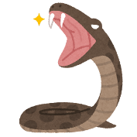
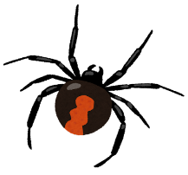

- _________________________________________________________________.
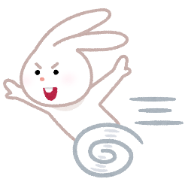
cool: strong; beautiful; interesting; old; new; funny; tall; small; heavy; light; smart; fast; slow; delicious; healthy; cute; sleepy; dangerous

Round 3 – Challenge! Use your own ideas
- ＿＿＿＿＿＿＿＿＿＿＿＿＿＿＿ is/are as＿＿＿＿＿＿＿＿＿＿＿＿＿＿as＿＿＿＿＿＿＿＿＿＿＿＿＿＿＿＿＿＿＿＿＿＿＿＿＿＿＿＿＿＿＿＿＿.
- ＿＿＿＿＿＿＿＿＿＿＿＿＿＿＿ is/are as＿＿＿＿＿＿＿＿＿＿＿＿＿＿as＿＿＿＿＿＿＿＿＿＿＿＿＿＿＿＿＿＿＿＿＿＿＿＿＿＿＿＿＿＿＿＿＿.
BONUS – Idioms
- As cool as a cucumber「キュウリのように冷たい」
  - 意味）落ち着き払っている／冷静な／ゆったりしている／気楽な
  - 例）Everyone was stressed, but she was as cool as a cucumber.
- A tale as old as time「時間のように古い」
  - 意味）時と同じくらい古い物語／昔から変わらない
  - 例）He lost all his money gambling… It’s a tale as old as time.

