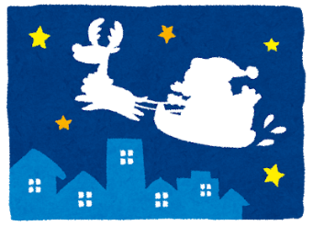
CHRISTMAS DASH
Name: ________________
Class: _____
Number: _____
ROUND ONE
- __________________________________________ (word)
- __________________________________________ (country)
- __________________________________________
- __________________________________________
ROUND TWO
- ___________________________________________
- ___________________________________________
- ___________________________________________ (items)
- ___________________________________________
ROUND THREE
- ___________________________________________
- ________________________________________
- ___________________________________________ (tool)
- ________________________________________ (fights)
ROUND FOUR
- ________________________________________
- ________________________________________ (taught)
- ________________________________________ (writing)
- ________________________________________
ROUND ONE
- What is a word starting with Q?
- What is a country starting with B?
- What is a food ending with R?
- What is an animal ending with T?
ROUND TWO
- What is a food made at home?
- What are houses made from snow?
- What are items made by SONY?
- What are animals seen in China?
ROUND THREE
- What is the sport the Giants play?
- What are animals people have at home?
- What is a tool Doraemon uses for flying?
- Who is the character Anpanman fights every week.
ROUND FOUR
- What do you like seen in the park?
- What do you study taught by Robert?
- What do you have used for writing?
- What do you eat made from rice?

