Were you…? / Did you…?
(Are you…?/Do you…? の過去形)
Yes, I was. / No, I wasn’t
an elementary school student last year?  name: ____________ | 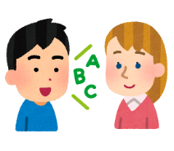  speak English yesterday?  name: ____________ | happy yesterday?  name: ____________ | sleepy this morning?  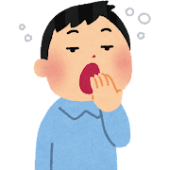  name: ____________
drink cola yesterday?  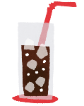  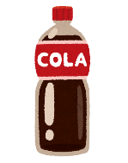  name: ____________ | a JHS student yesterday?  name: ____________ | eat rice for breakfast?  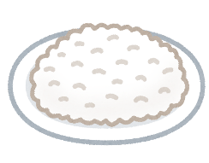  name: ____________ | cold this morning?  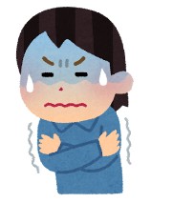  name: ____________
sing karaoke on Saturday?  name: ____________  j | Japanese yesterday?  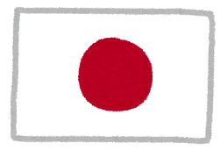  name: ____________ | a teacher yesterday?  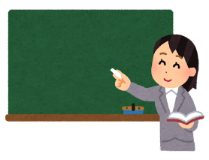  name: ____________ | 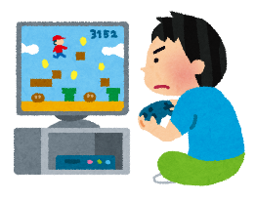  play games yesterday?  name: ____________
read manga last week?  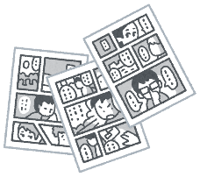  name: ____________ | at home yesterday?  name: ____________ | like anime yesterday?  name: ____________ | play soccer last week?  name: ____________

Challenge! Write TWO sentences:
例）Tom spoke English yesterday / Tom was happy yesterday.
(原形 ➜ 過去形 speak ➜ spoke / is ➜ was)
- ＿＿＿＿＿＿＿＿＿＿＿＿＿＿＿＿＿＿＿＿＿＿＿＿＿＿＿＿＿＿＿＿＿＿＿＿＿＿＿.

- ＿＿＿＿＿＿＿＿＿＿＿＿＿＿＿＿＿＿＿＿＿＿＿＿＿＿＿＿＿＿＿＿＿＿＿＿＿＿＿.

