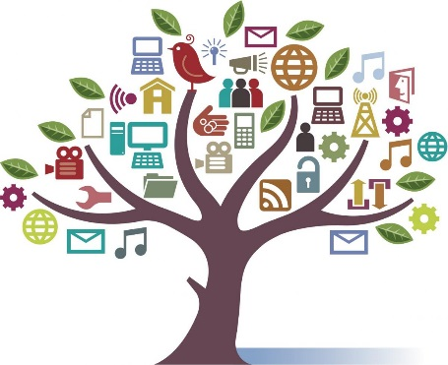
Media Diet

What kind of media do you watch, read, or listen to?

What are the good parts and bad parts about different kinds of media?

 | Radio | TV | Newspapers | Social Media (Twitter, Facebook)
good
bad

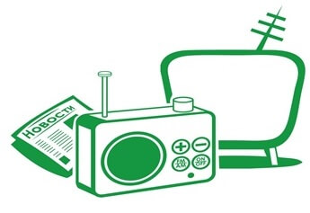

How should people use media?
What do you think is the best idea for children…

…and adults?

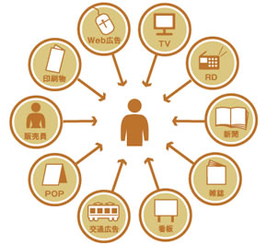
Should there be any laws about different kinds of media in the future?

