Feelings!
I.) Match! (Write the word under the picture)
Satisfied | _______________ | _______________ | _______________
_______________ | _______________ | _______________ | _______________
_______________ | _______________ | _______________ | _______________
_______________ | _______________ | _______________ | _______________

Satisfied | Angry | Powerful | Uncomfortable
Happy | Relaxed | Lonely | Calm
Tired | Positive | Refreshed | Scared
Shocked | Confused | Shy | Thankful
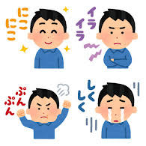
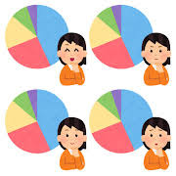
II.) Expressing Feelings! (感情を表わそう！)
“When I ① ②, I feel ③.” = 「 ②を①時、③。」
Examples
- When I study Japanese, I feel motivated. = 日本語の勉強する時、やる気が出ます。
- When I teach English, I feel excited. = 英語を教える時、わくわくします。
1.) When I hear the first song, I feel ___________________.
2.) When I hear the second song, I feel ___________________.
3.) When I hear the third song, I feel ___________________.
4.) When I hear the fourth song, I feel ___________________.
5.) When I hear the fifth song, I feel ___________________.
6.) When I see the first TV scene, I feel ___________________.
7.) When I see the second TV scene, I feel ___________________.
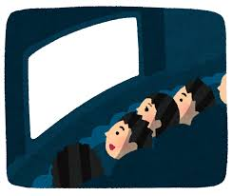
8.) When I see the third TV scene, I feel ___________________.
9.) When I see the fourth TV scene, I feel ___________________.
10.) When I see the fifth TV scene, I feel ___________________.

11.) When I read books, I feel ____________________.
12.) When I play sports, I feel ____________________.
13.) When I go home, I feel _____________________.
14.) When I ______________________, I feel _______________________ because ___________________________________________________________________.

