

Find the clues!

Solve the Mystery!

Name: ________________ Class: 1-____

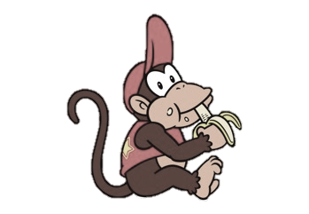

Wario

____ ____ ____ ____ ____ ____ ____ ____ ____ ____ ____ ____

____ ____ ____ ____ ____ ____ ____ ____ ____ ____ ____ ____ ____ ____



Diddy

____ ____ ____ ____ ____ ____ ____ ____ ____ ____ ____ ____

____ ____ ____ ____ ____ ____ ____ ____ ____ ____ ____ ____ ____ ____

Luigi

____ ____ ____ ____ ____ ____ ____ ____ ____ ____ ____ ____

____ ____ ____ ____ ____ ____ ____ ____ ____ ____ ____ ____ ____ ____

Mario

____ ____ ____ ____ ____ ____ ____ ____ ____ ____ ____ ____

____ ____ ____ ____ ____ ____ ____ ____ ____ ____ ____ ____ ____ ____

Yoshi

____ ____ ____ ____ ____ ____ ____ ____ ____ ____ ____ ____

____ ____ ____ ____ ____ ____ ____ ____ ____ ____ ____ ____ ____ ____