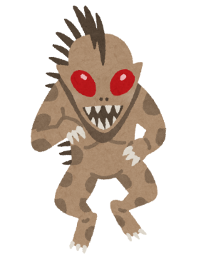
Name: _____________ Class: ____ Number: ____
ROUND ONE
happy | strong | hungry | sleepy | old
stop | eat | make | study | fight
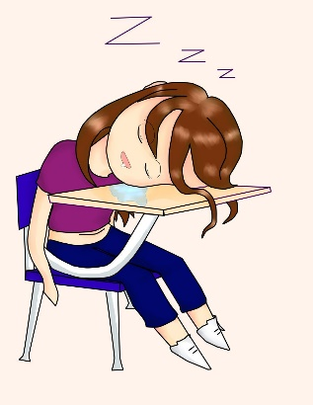
- That ________ is too _______ to _________.
- These ________ are too _______ to _________.
- She is too _______ to __________.
- She is too _______ to ________ eating.
ROUND TWO
fun | big | cute | expensive | difficult
play | buy | eat | playing | use
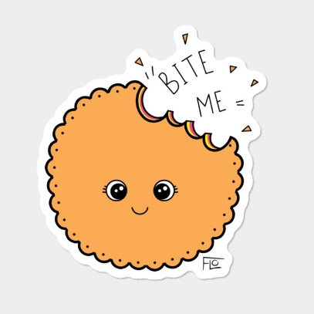
- These _______ are too _________ to _________.
- This ________ is too ________ to stop _________.
- This _________ is too ________ to __________.
- This ________ is too _______ to _________.
ROUND THREE
scary | hot | heavy | young | sick
go | carry | watch | use | play

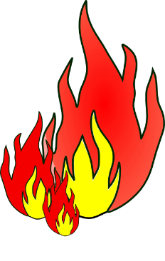
- ____________________________________________
- ____________________________________________
- ____________________________________________
- ____________________________________________
LAST
- ___________________________________________

