Name: _____________________ Class: ______
3

1. Send us your unused school ______, and we will donate them to children.
a. supplies b. backpacks c. pencils d. notebooks

2. Like most countries, Japan _______ on foreign trade.
a. relying b. depending c. needs d. depends

3. I wish I ________________________________________.
a. could go to school b. can go to school
c. can’t go to school d. went to school

4. This nurse is very tired. 彼女のコワーカーが言います, ’‘If I were you …………………….”
a. I’ll take a rest b. I can take a rest
c. I’d take a rest d. Id take a rest

5. If you _____ a time machine, you ______ travel to the future.
a. have, could b. had, could c. having, can d. has, can’t

6. If it were sunny today, ____________________________________. （絵をよく見てね！）
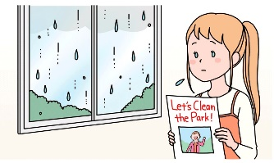
a. I would stay inside b. we would clean the park
c. I could keep reading this book d. we couldn’t go swimming

7. I have 12 dogs. （会える質問は何ですか）
a. How are the dogs? b. How many dogs do you have?
c. How many dogs are there? d. How many dog do you have?

8. A furoshiki is a piece of cloth that is ________ for carrying things.
a. useful b. uses c. used d. using

9. How long have you lived here? a. for 20 years b. We don’t live here now.
c. We have just moved here. d. We haven’t moved yet.

10. The man _______ the black cap is Leonardo di Caprio
a. wearing b. wears c. worn d. wear

11. I always read a book _______ I go to sleep.
a. before b. after c. if d. when

12. We have our __________ ceremony on March 13th.
a. leaving b. parting c. goodbye d. graduation

13. Many people work at Apple. It has a lot of _____________.
a. staff b. workers c. employees d. salarymen

14. I have been a junior high school student _______________________. 正しい答え二つ！
a. for three years b. since three years ago
c. three years ago d. since 2020

15. I’d like a steak and salad.
a. What do you like? b. What would you like?
c. What do you want? d. What do you have?

16. Tokyo Sky Tree is taller than Tokyo Tower. True False

17. __________ books is a good way to relax.
a. Read b. Reading c. Reads d. Readed

don’t have to | in Australia | clean the school | students

18. ___________________________________________________________________

19. Is there an aquarium in your town?
a. No, there isn’t. b. No, there is. c. Yes, there is. d. Yes, their is.

20. You _________ tell anyone your PIN number.
a. must b. have to c. don’t have to d. mustn’t

21. Your ALT has never been to Japan. True False
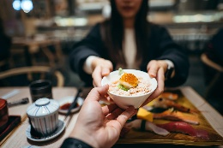
22. What do you say? a. Here you are. b. Here are you.
b. Here it is. b. It’s here.

him | getting hugs | happy | makes
23.
_____________________________________________________________________

24. Badminton is a sport which uses a ball. True False

25. Tom Cruise is an actor _____ does _____ own stunts.
a. who, his b. which, its
c. that, her d. that, him

